**Assignment:** Snap-in Development Challenge Submission

## **Step 2** : Creating and Installing a Snap-in

Second task is to create and install a snap-in. Submission should include:

1. Code for the "hello world" snap-in.

2. Instructions on how to install and use the snap-in.

3. A screenshot or demonstration of the snap-in.

**Problem Statements that were executed in Snap-In Challenge are:**

1. Schedule a reminder for someone by tagging them on a work item after MM HH DD time. Where MM is the minute, HH is the hour and DD is the time.
2. Command to clone a work item (issue/ticket).
3. Auto-Reply to a message if it is outside office hours. The start and end time for office hours can be specified in the input. The auto-reply message can also be taken as an input.

**Brief explanation on what are Snap-in:**

Snap-ins are collections of objects that extend DevRev’s core platform value, allowing developers to develop at “arms-length” without making changes to the core platform, by interacting with DevRev objects through APIs, receiving updates through webhooks, and subscribing to external events via registered event sources such as GitHub or Slack.

**Before creation of Snap-in a few prerequisites needs to be installed into the user system:**

1. **Install DevRev CLI:**

1. Download the Windows executable for the supported architecture (Windows amd64).

2. Unzip the downloaded file.

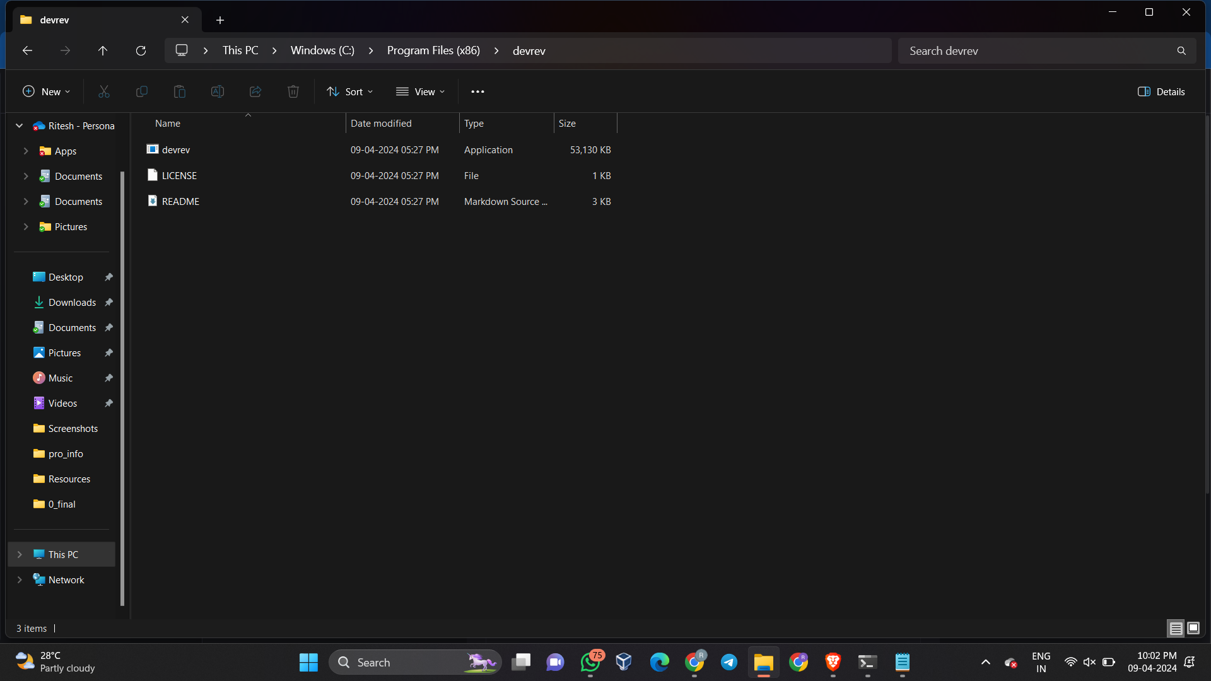

3. Add the path to the environment variable:

- Open System Properties > This PC > Properties.

- In the System window, click Advanced system settings > Environment Variables > Path > Edit.

- In the Edit environment variable window, click New.

- Enter the path to the directory you want to add, for example: C:\Program Files\devrev\

- Click OK to save the changes.

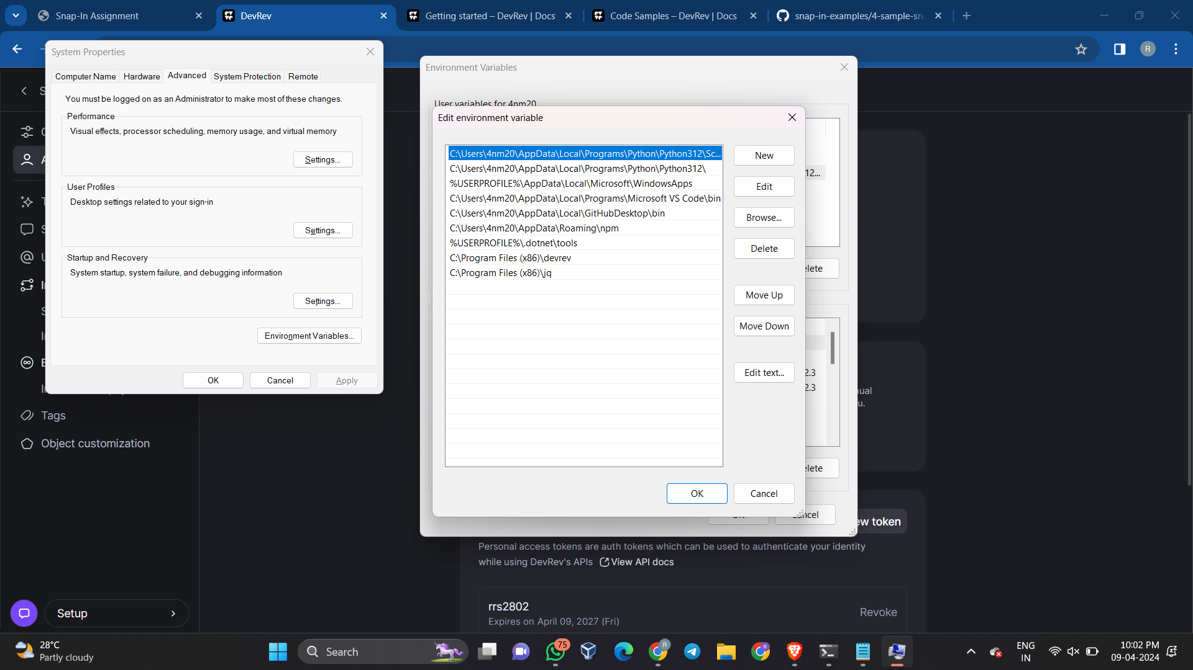

4. Close all remaining windows by clicking OK.

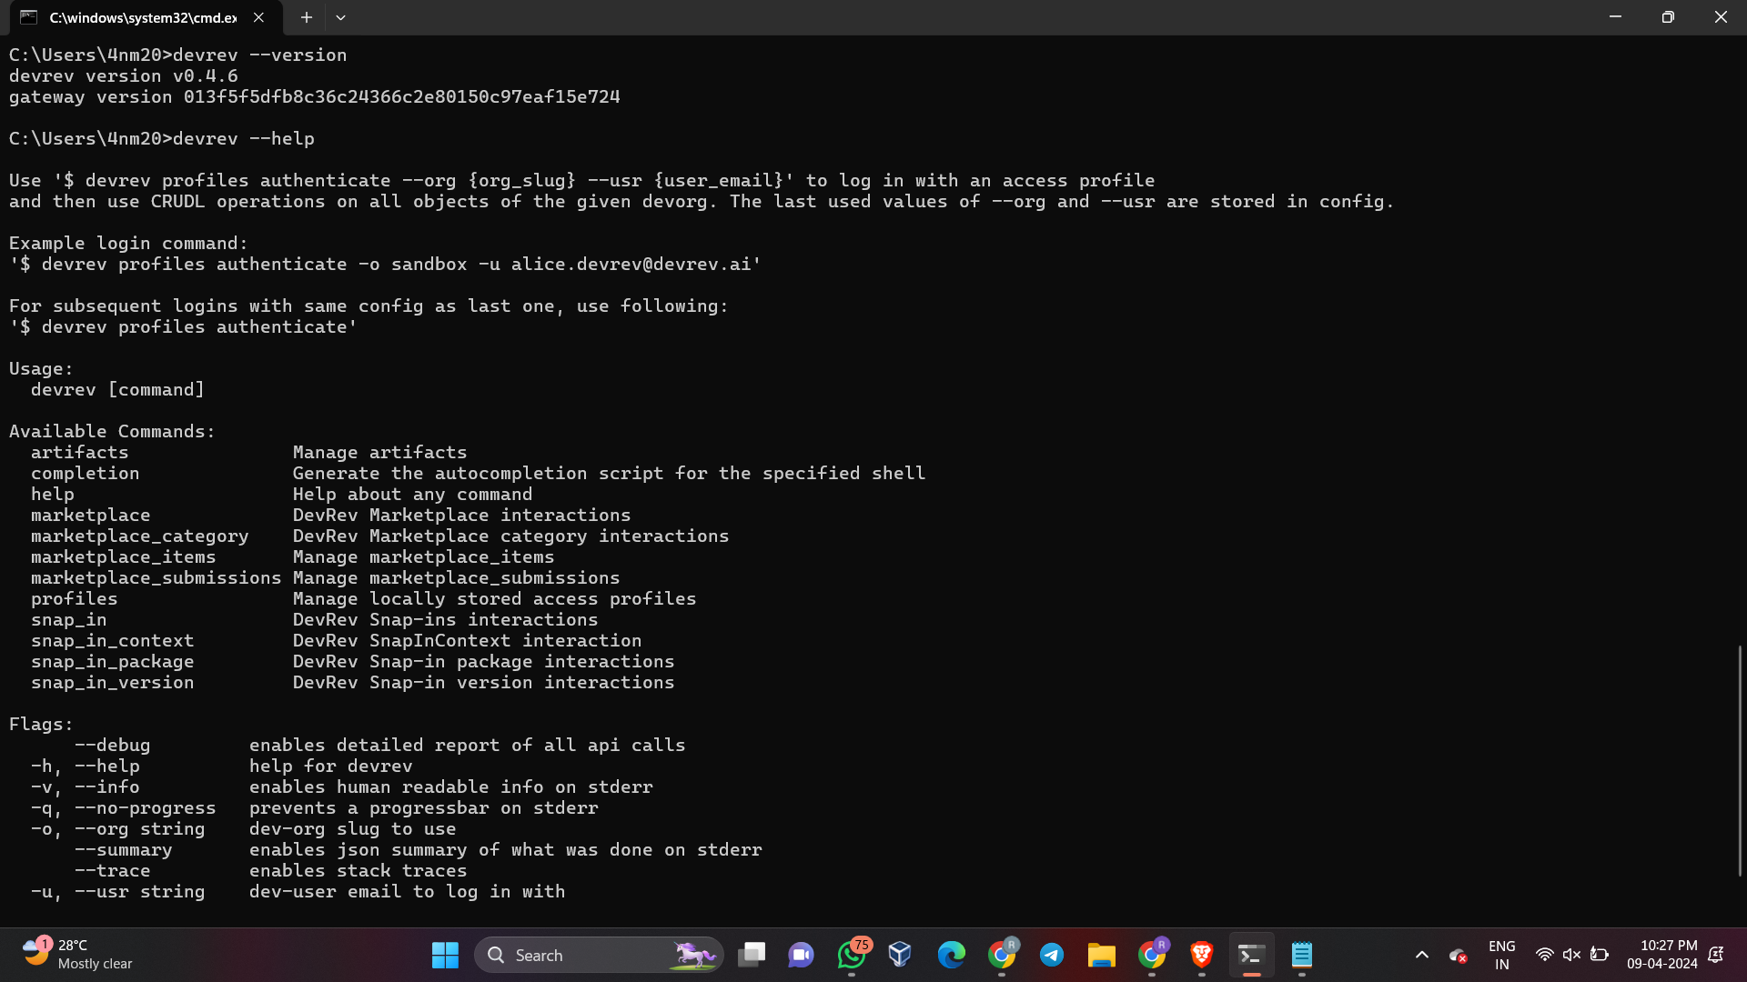

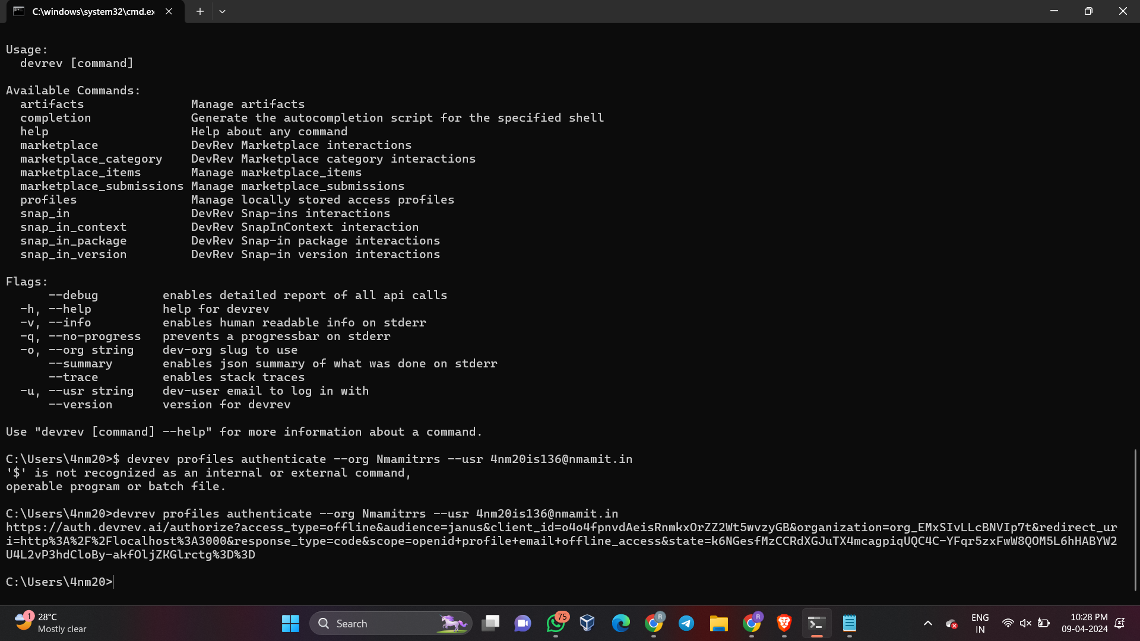

**Output:**

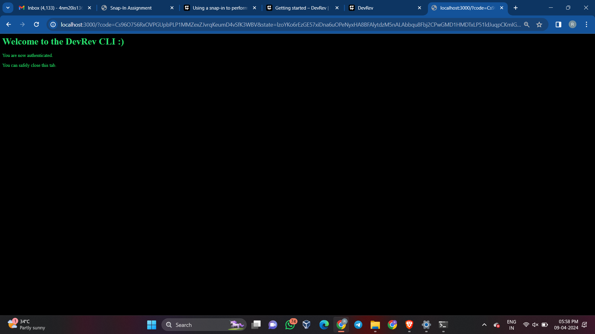

1. **Install jq:**

1. Open web browser and go to the official jq website at https://stedolan.github.io/jq/download/.

2. Scroll down to the Windows section and find the link to download the precompiled binary. It will be a .zip file.

3. Once the download is complete, extract the contents of the .zip file to a location on your local system, such as C:\Program Files(x86)\jq.

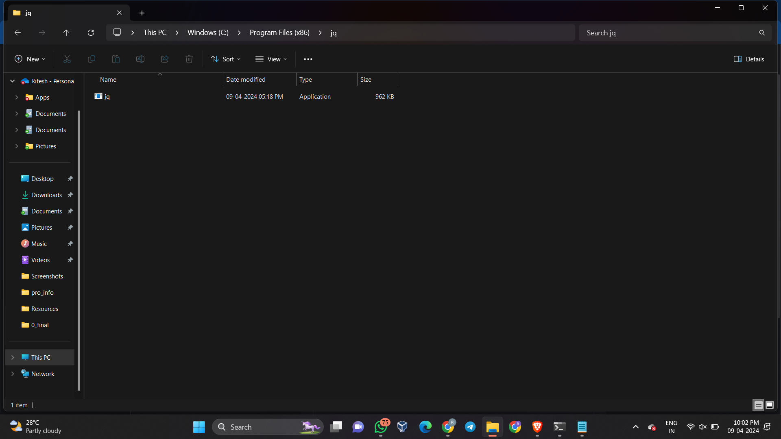

4. Next, add the directory where you extracted the jq binary to your system's PATH environment variable. This will allow you to run jq from any location in the command prompt.



5. Finally, open a new command prompt window to ensure that the changes to the PATH environment variable take effect, and then type "jq --version" to verify that jq has been successfully installed. If the installation was successful, you should see the version of jq that you downloaded.

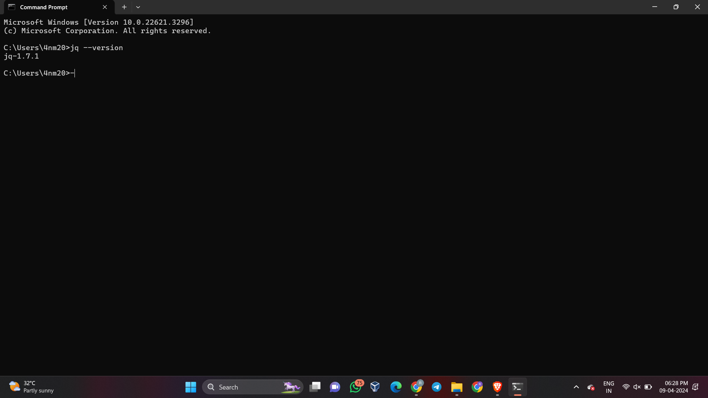

1. **Install DevRev SDK:**

1. Set up an environment variable named DEVREV_TOKEN. This token will be used as an authentication token by default. You can also pass in the URL and token in client.setup() as a parameter. This token is also required to run tests.

2. Open your terminal or command prompt.

3. Run the following command to install the @devrev/typescript-sdk package using npm:

```

npm install @devrev/typescript-sdk

```

4. Verify that the installation was successful by checking the package.json file in your project. Make sure that your project's package.json contains the "type":"module" setting, as the SDK is currently in beta.

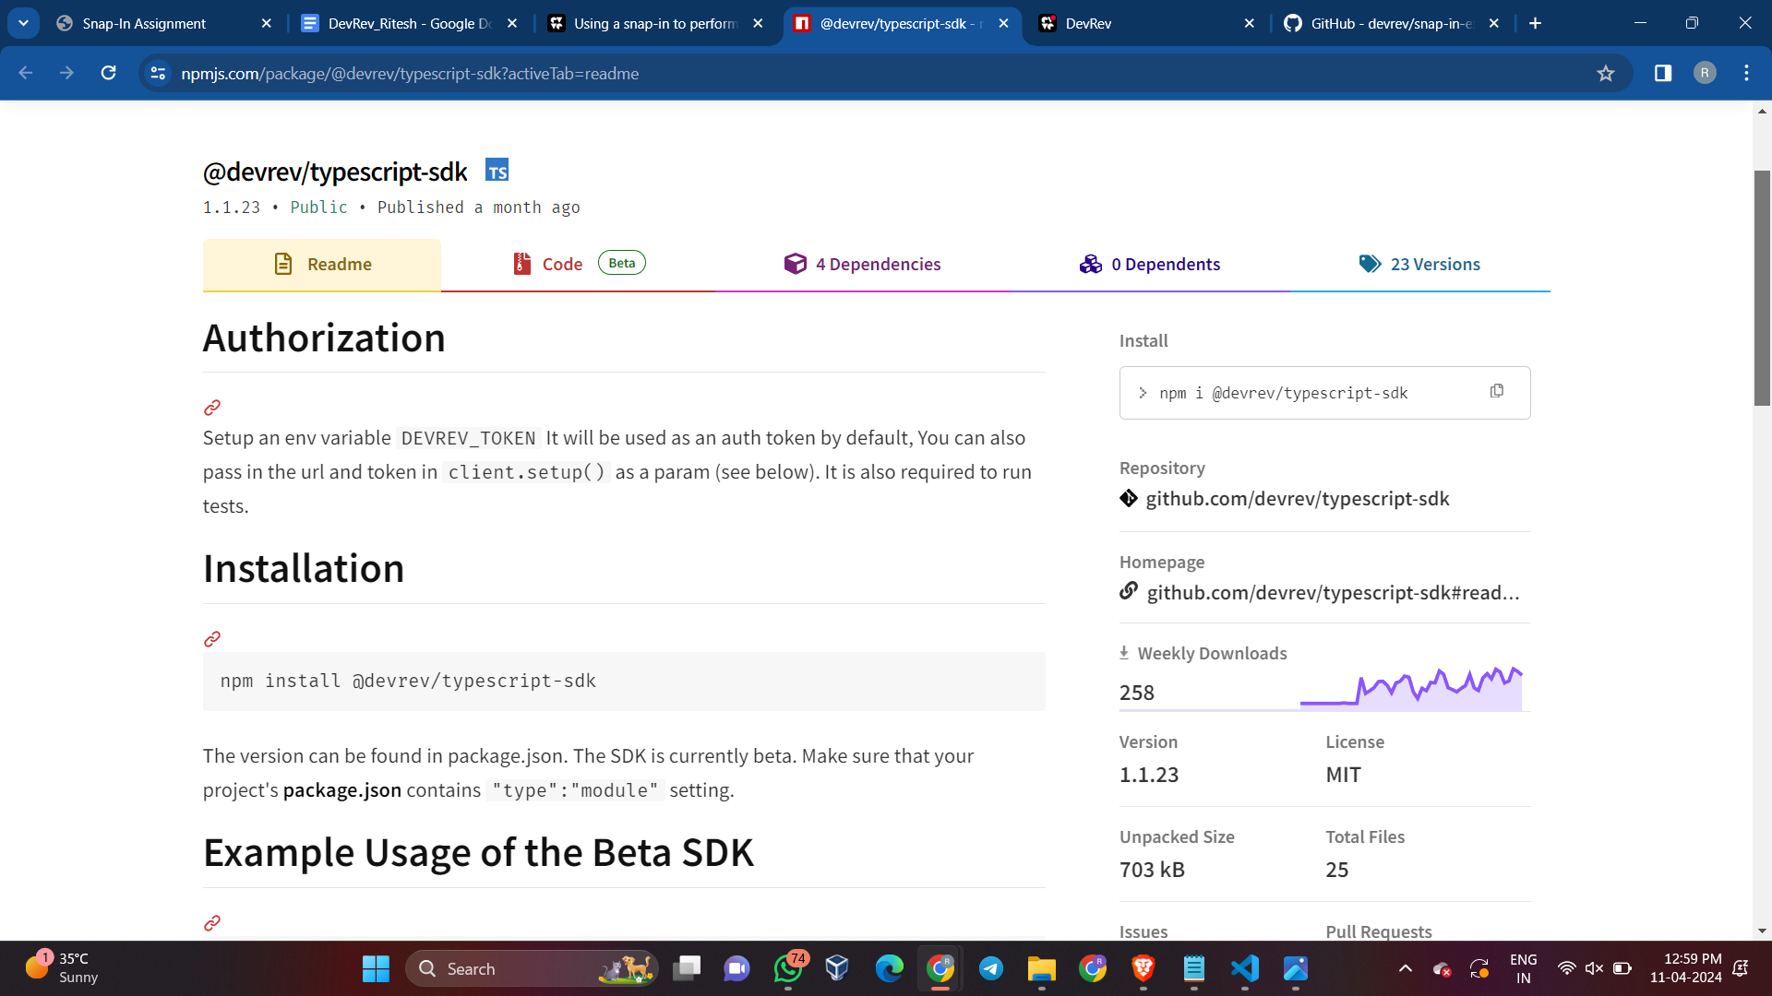

**To create a snap-in using the provided content, you can follow these steps:**

1. Open your terminal or command prompt.

2. Run the following command to initialize a snap-in template:

```

devrev snap_in_version init

```

3. After running the command, a new folder named devrev-snaps-typescript-template will be created in the filesystem. This folder will contain a manifest.yaml file and a code folder with the following structure:

```

devrev-snaps-typescript-template/

├── code

│ ├── babel.config.js

│ ├── jest.config.js

│ ├── nodemon.json

│ ├── package.json

│ ├── src

│ │ ├── fixtures

│ │ │ └── on_work_created_event.json

│ │ ├── function-factory.ts

│ │ ├── functions

│ │ │ └── on_work_creation

│ │ │ ├── index.test.ts

│ │ │ └── index.ts

│ │ ├── index.ts

│ │ ├── main.ts

│ │ └── test-runner

│ │ ├── example.test.ts

│ │ └── test-runner.ts

│ ├── tsconfig.eslint.json

│ └── tsconfig.json

├── manifest.yaml

└── README.md

```

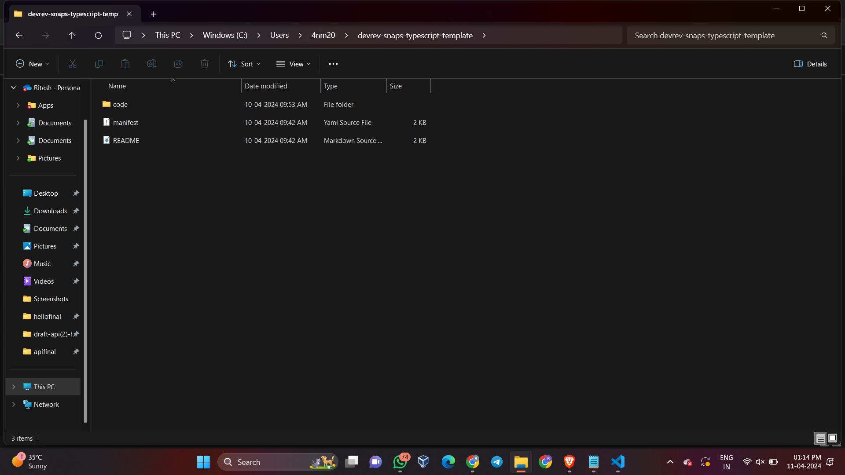

4. The manifest.yaml file defines the resources to be created on the DevRev platform.

5. The code folder contains sample starter code for snap-ins. For detailed information on how to get started, you can refer to the starter example repo.

**Creating a snap-in package:**

1. Run the following command to create a snap-in package, replacing "helloworld" with a globally unique slug:

```

devrev snap_in_package create-one --slug my-first-snap-in | jq .

```

- Note: If the provided slug is already taken, a conflict error will occur. In this case, provide a different unique slug.

2. Upon successful creation, the CLI automatically stores the package ID in its context corresponding to the slug.

**Creating a snap-in version:**

1. Run the following command to create a snap-in version, specifying the path to the devrev-snaps-typescript-template folder:

```

devrev snap_in_version create-one --path ./devrev-snaps-typescript-template | jq .

```

2. The output will include the version ID and other relevant information. The CLI automatically stores the version ID in its context.

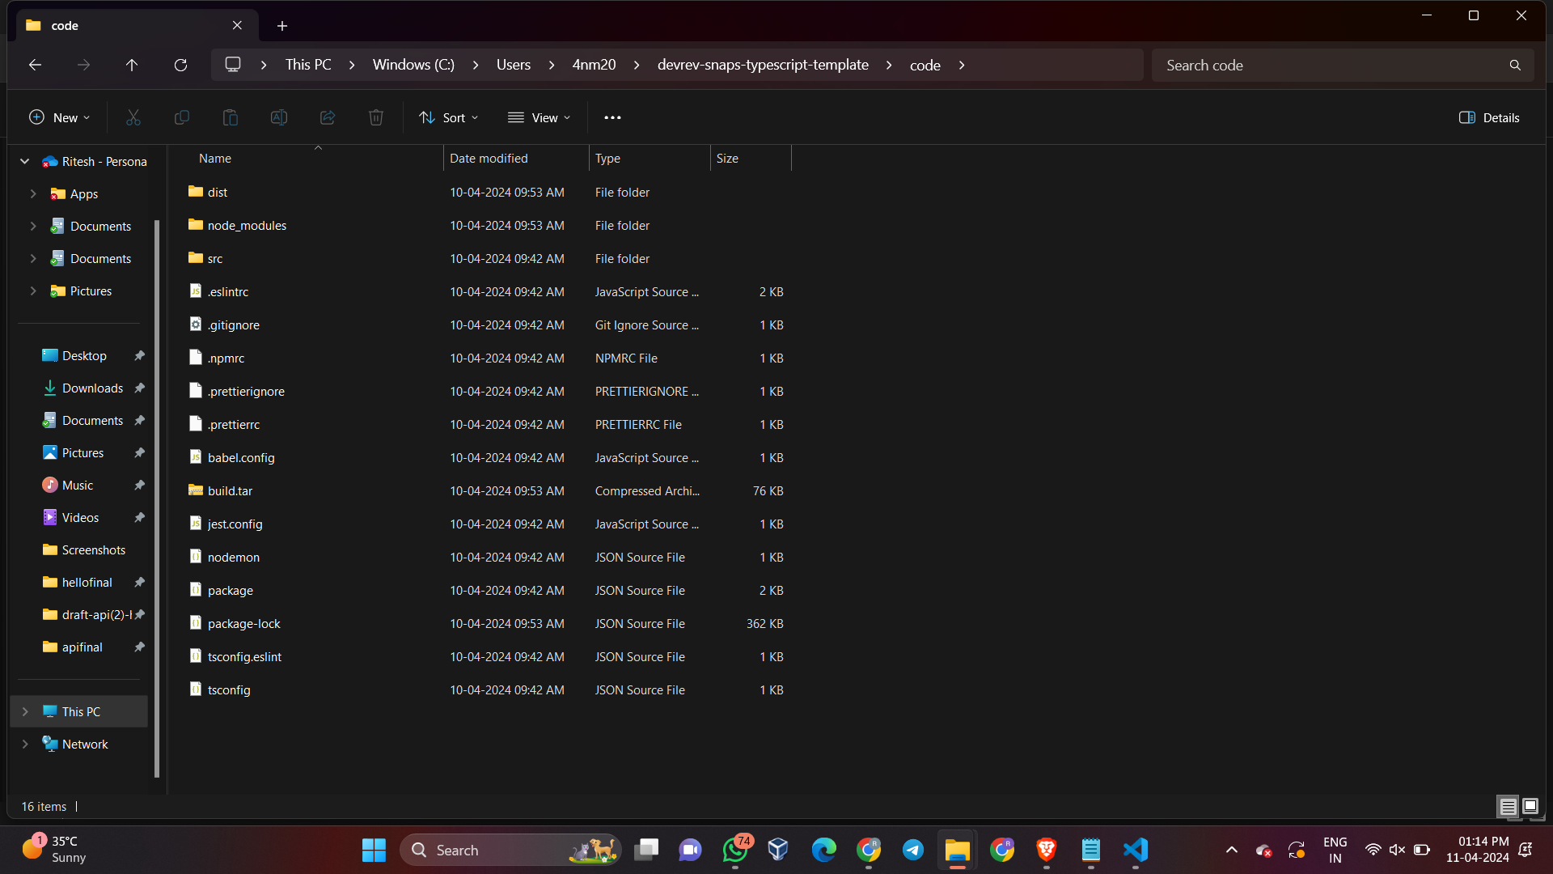

**Explanation of code in Snap-in manifest file in context to Snap-in Development:**

**1. Version and Information:**

- The "version" field specifies the version of the snap-in manifest.

- "name" and "description" provide a name and description for the snap-in.

**2. Service Account:**

- The "service_account" section specifies the display name of the service account that will take actions using the token of this service account.

**3. Event Sources:**

- The "event_sources" section defines the event sources that the snap-in will listen to.

- In this case, it references an organization event source named "devrev-webhook" that supports the "work_created" event type.

**4. Inputs:**

- The "inputs" section defines the organization level inputs for the snap-in.

- It includes input fields such as text, boolean, and array types, along with their descriptions, default values, and UI display names.

**5. Functions:**

- The "functions" section lists the functions available in the snap-in, along with their descriptions.

- In this case, it includes "function_1" and "function_2" with their respective descriptions.

**6. Automations:**

- The "automations" section specifies the automations that the snap-in will perform.

- It includes an automation named "convergence_automation_devrev" that is triggered by the "work_created" event from the "devrev-webhook" event source and calls "function_1".

**7. Commands:**

- The "commands" section defines commands that can be used to trigger specific functions within the snap-in.

- In this case, it includes a command named "helloworld" that triggers "function_2" and provides usage hints and supported object types.

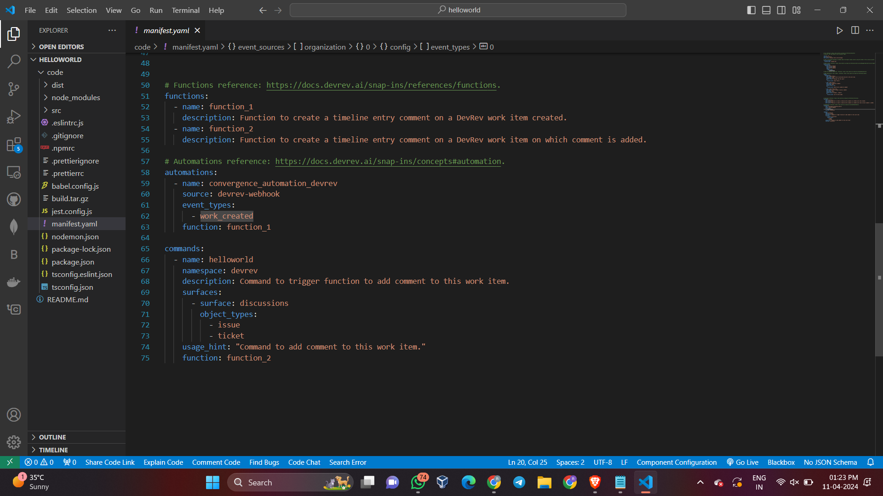

**Explanation of code in Snap-in Functions and Logic defined for Snap-in Development:**

**1. Importing the Required Module:**

- The code begins with importing the necessary module, in this case, "@devrev/typescript-sdk".

**2. Defining the handleEvent Function:**

- The "handleEvent" function is defined as an asynchronous function that takes an "event" parameter.

**3. Accessing Event Context and Setup:**

- Within the "handleEvent" function, the necessary event context values such as "service_account_token" and "devrev_endpoint" are accessed for authentication and API endpoint setup.

**4. Setting up the DevRev SDK Client:**

- The "client.setup" method is used to set up the DevRev SDK client with the specified API endpoint and authentication token.

**5. Handling Event Data:**

- Relevant event data is extracted based on the specific event payload and input data, and any necessary processing is performed.

**6. Creating and Sending a Request:**

- A request body is constructed based on the event data and a specific action, such as creating a timeline comment.

- The constructed request is sent using the DevRev SDK client, and the response is awaited.

**7. Defining the run Function:**

- The "run" function is defined as an asynchronous function that takes an array of "events" as a parameter.

**8. Iterating Through Events:**

- Within the "run" function, a loop iterates through the array of events, calling the "handleEvent" function for each event.

**9. Logging and Exporting:**

- Relevant information, such as event details and response data, is logged or processed as needed.

- The "run" function is exported as the default export, making it available for use in other modules.

**Steps and Commands involved to Run Snap-in:**

**1. Packaging the Code:**

- Run the following commands to package the code:

**- `npm install`**

**- `npm run build`**

**- `npm run package`**

- Ensure that the process succeeds, and a **"build.tar.gz"** file is created, which can be provided when creating the snap_in_version.

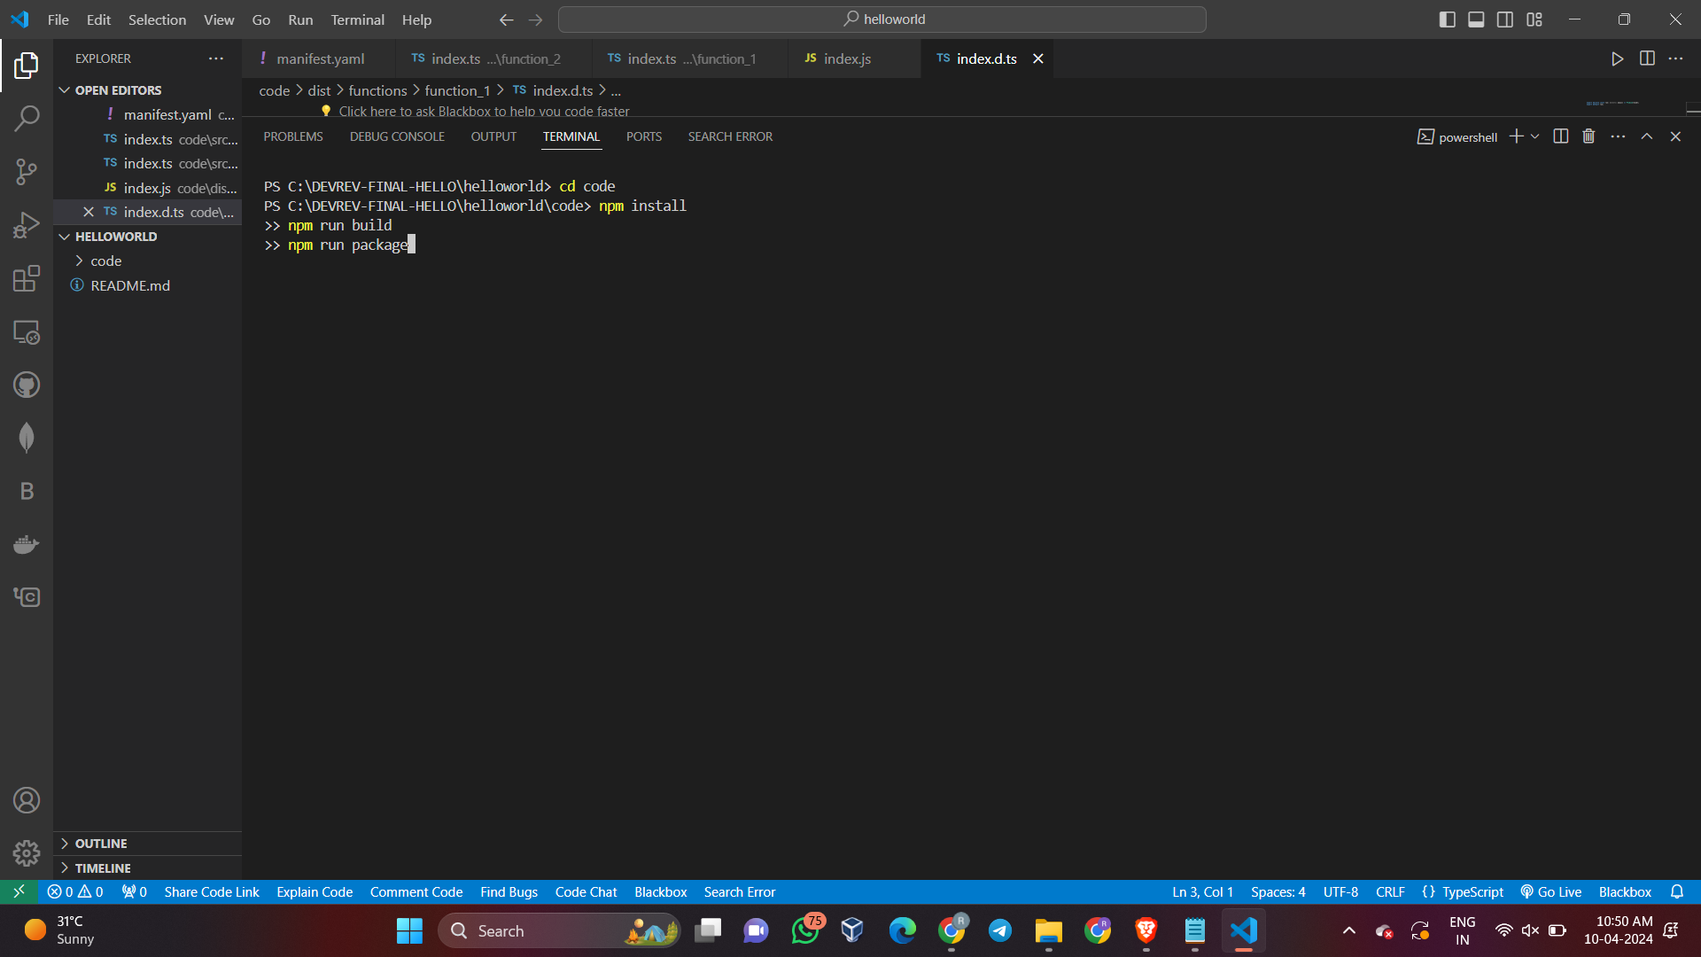

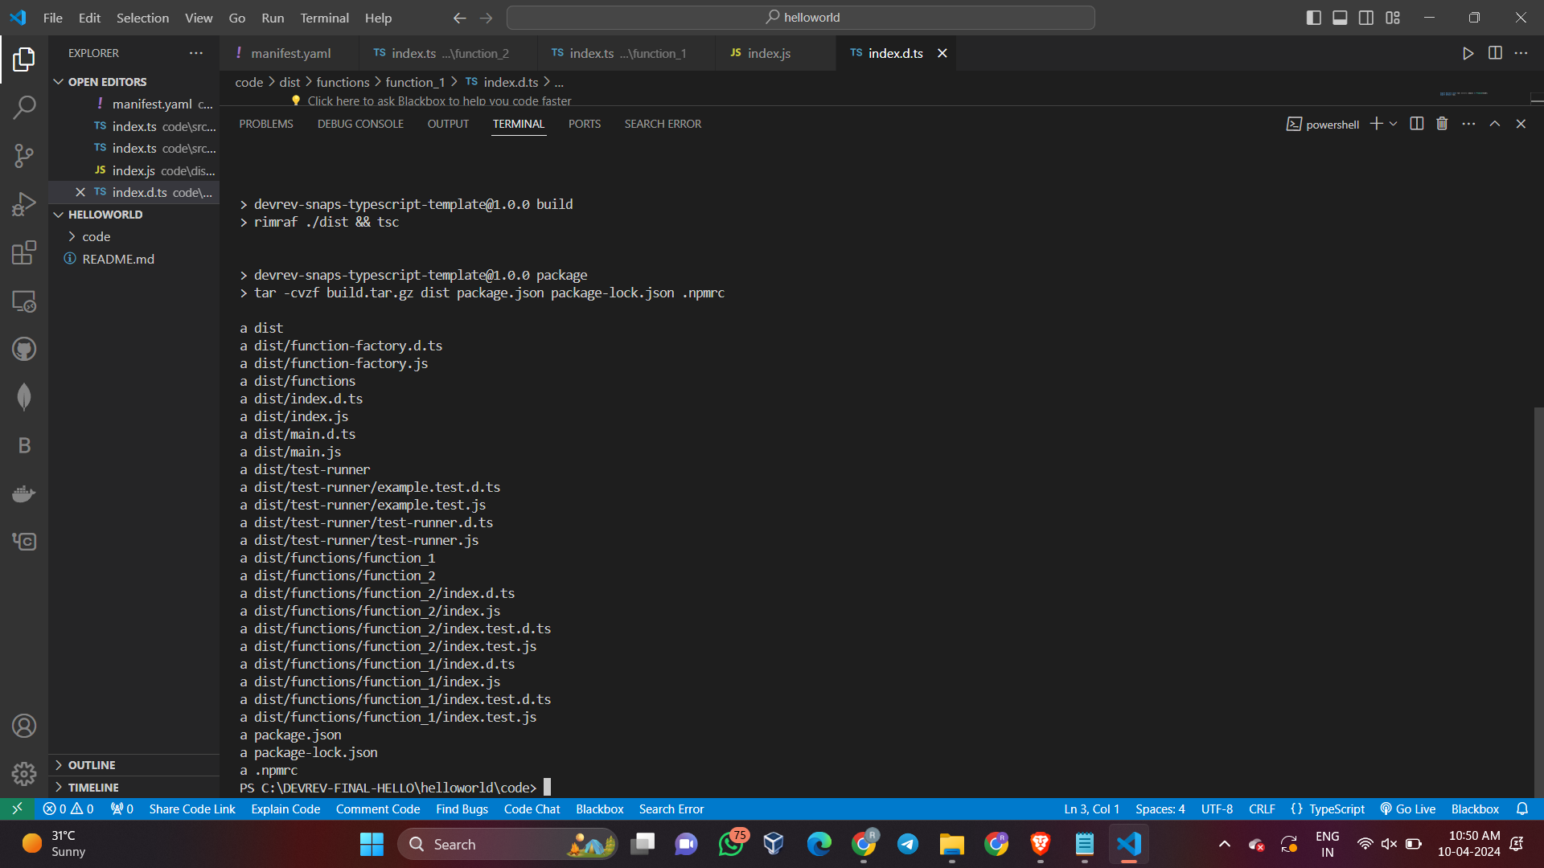

**2. Authentication:**

- To authenticate, run the command:

```

**devrev profiles authenticate --org <DevOrg-slug-name> --usr <your-email@example.com>**

```

- Replace `<DevOrg-slug-name>` with the unique slug name of your DevOrg, and `<your-email@example.com>` with your registered user email for the profile.

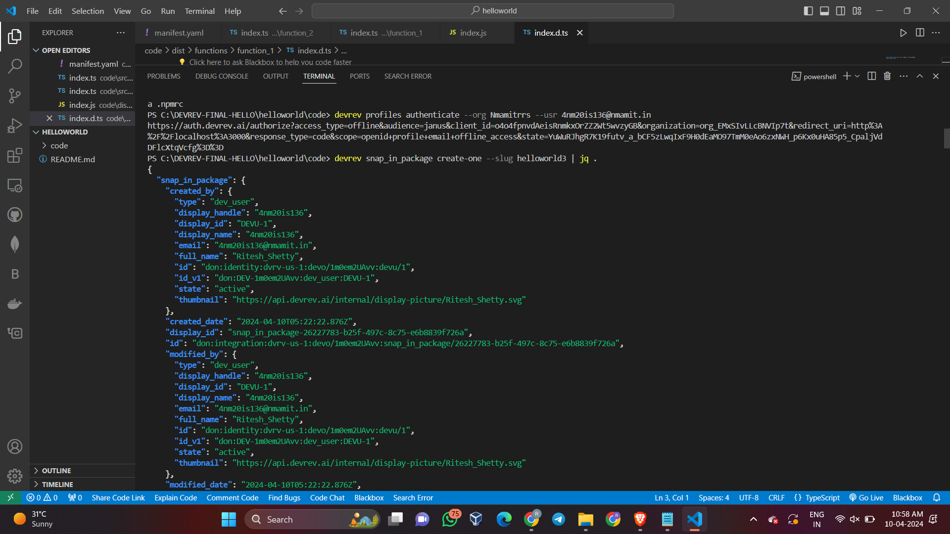



**3. Snap-in Package:**

- Create a snap-in package by running the command:

```

**devrev snap_in_package create-one --slug <slug name>| jq .**

```



**4. Snap-in Version:**

- Create a snap-in version by running the command:

```

**devrev snap_in_version create-one --manifest manifest.yaml --archive build.tar.gz | jq**

```

- For example: `devrev snap_in_version create-one --path ./code`

- Once the snap_in_version is created, its ID is stored in the snap-in context.

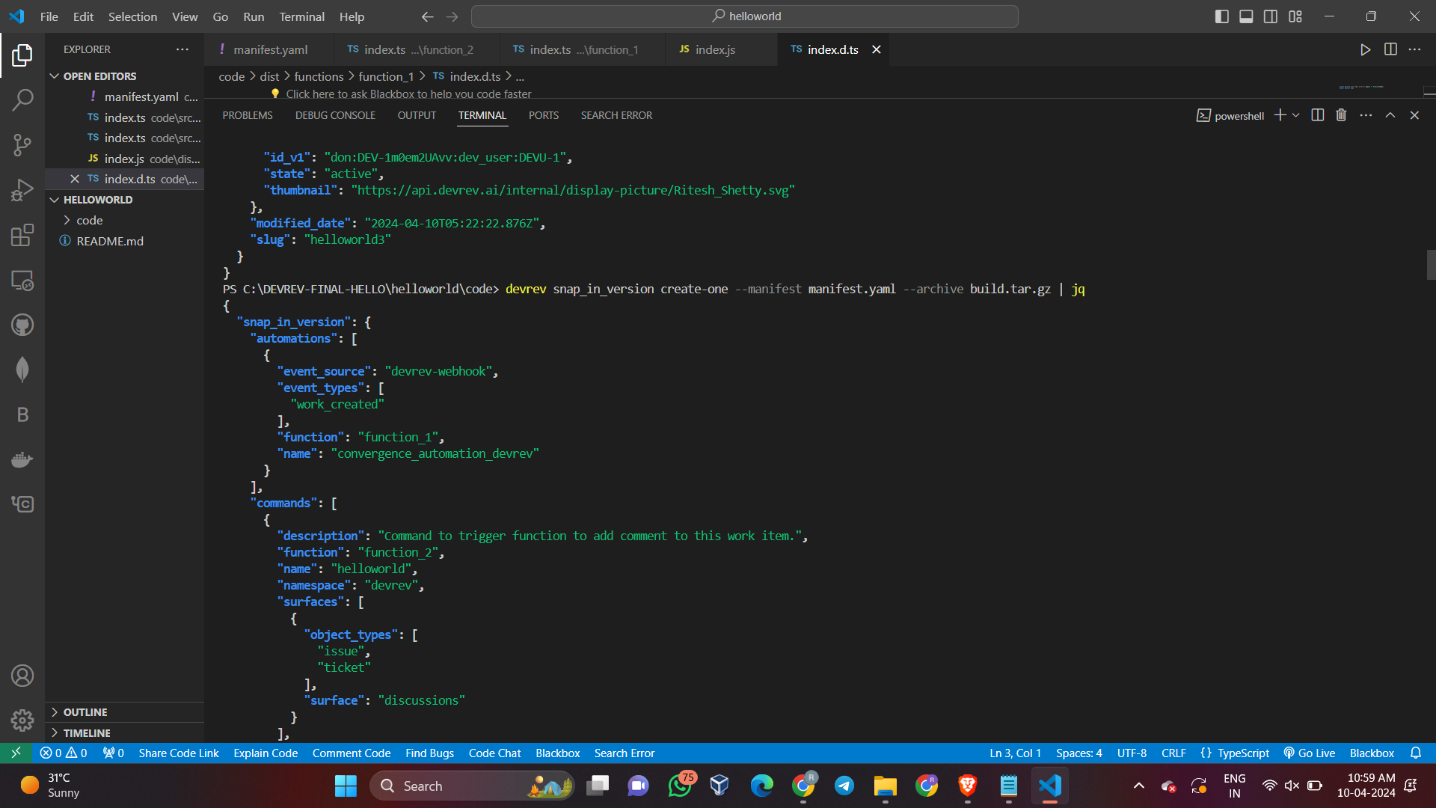

**5. Show Snap-in Details:**

- To show the snap-in details, run the command:

```

**devrev snap_in show [id] | jq .**

```

- `[id]` is optional. If not provided, it uses the ID stored in the local profile.

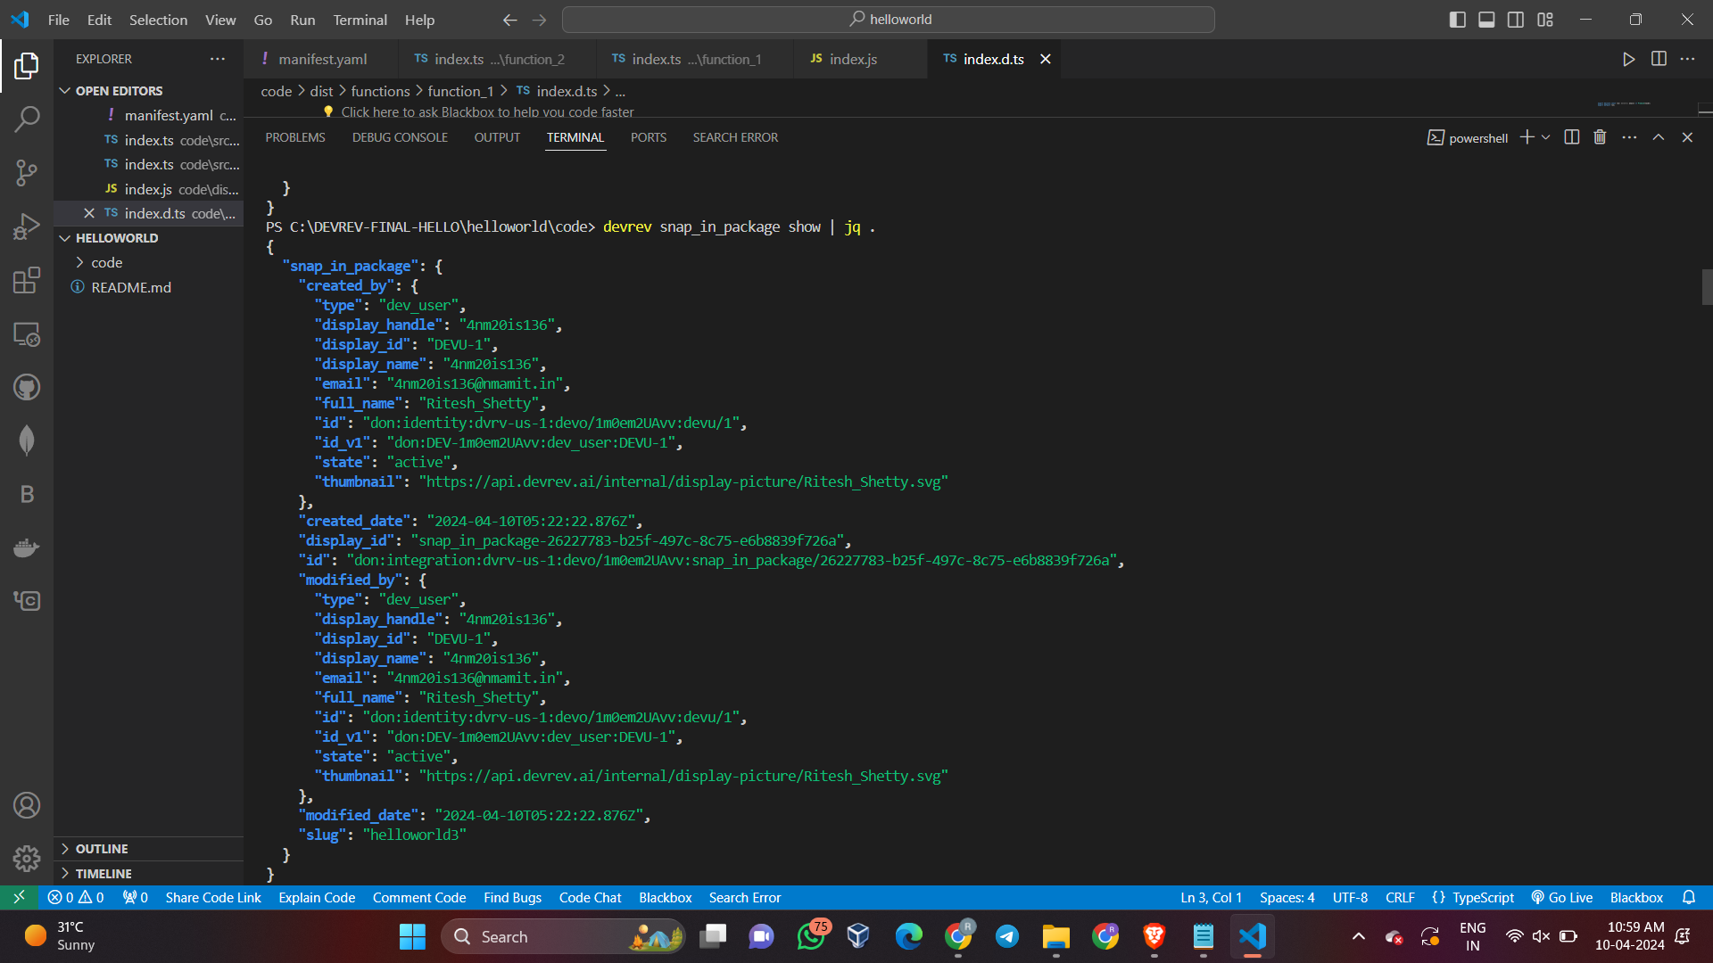

**6. Create Snap-in Draft:**

- To create a snap-in draft instance, run the command:

```

**devrev snap_in draft --snap_in_version [id]**

```

- For example: **`devrev snap_in draft | jq .`**

- The `--snap_in_version [id]` flag is optional. If not provided, it uses the snap-in version ID from the snap-in context.

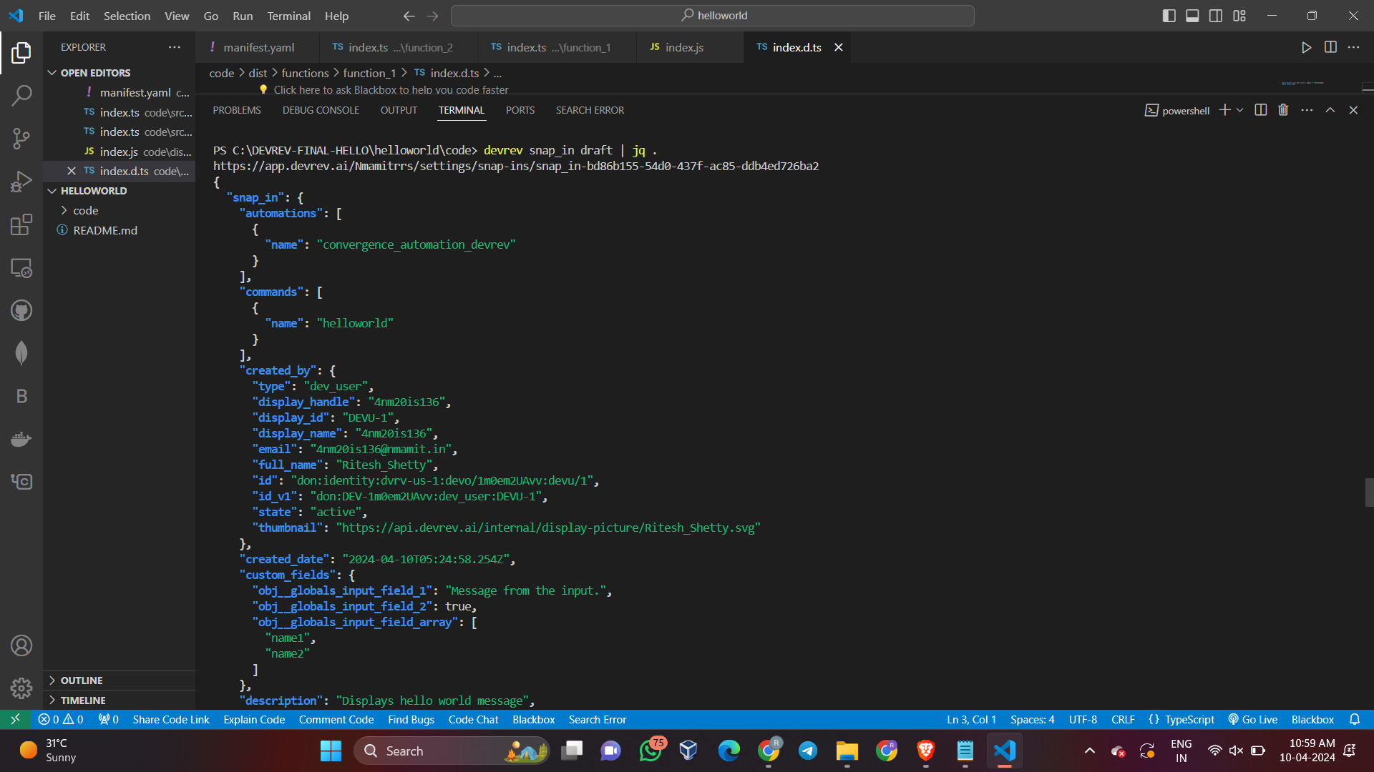

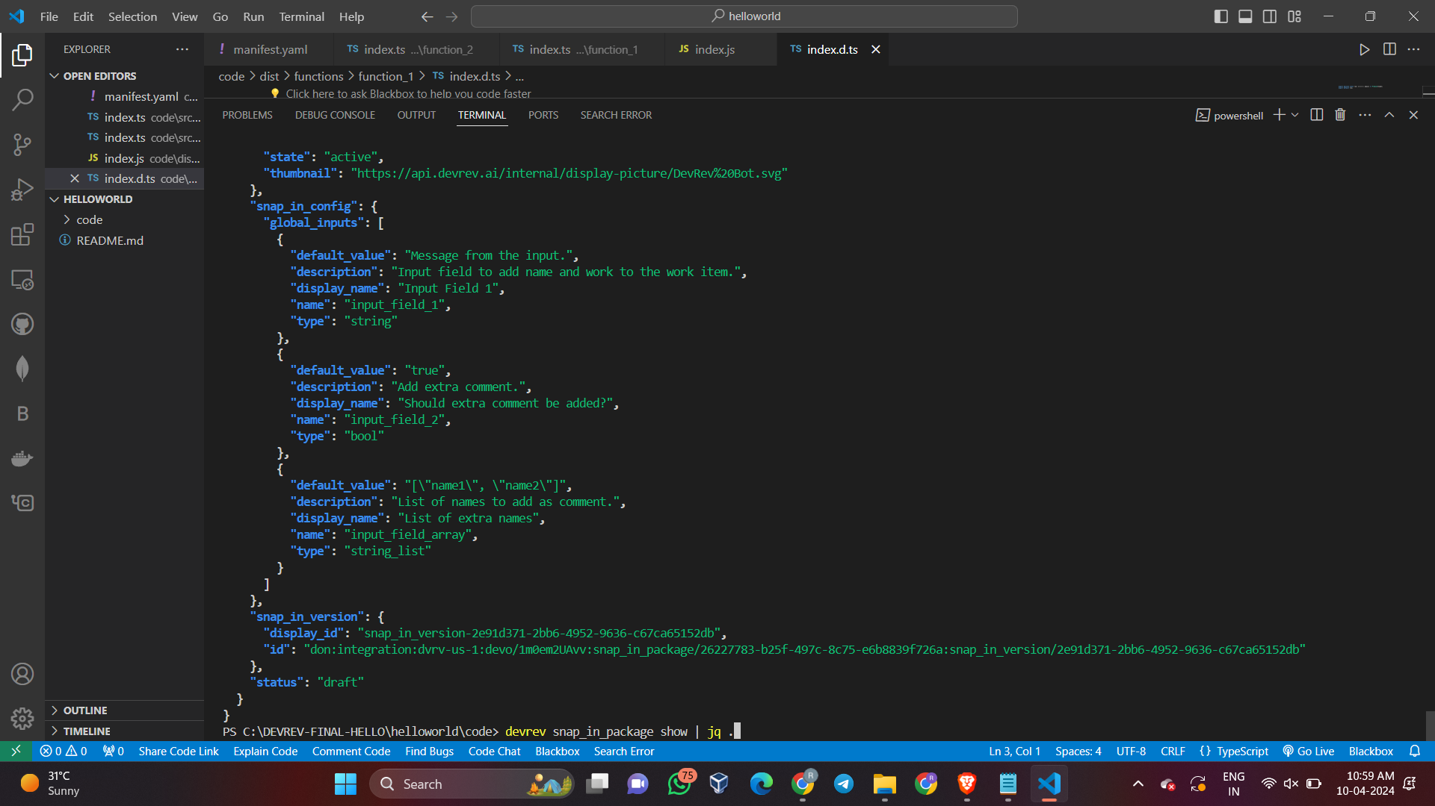

**Output For Hello-World Snap-in:**

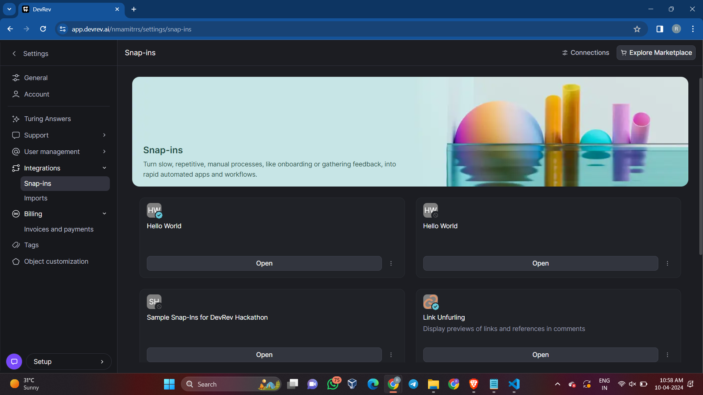

**Configure and Deploy:**

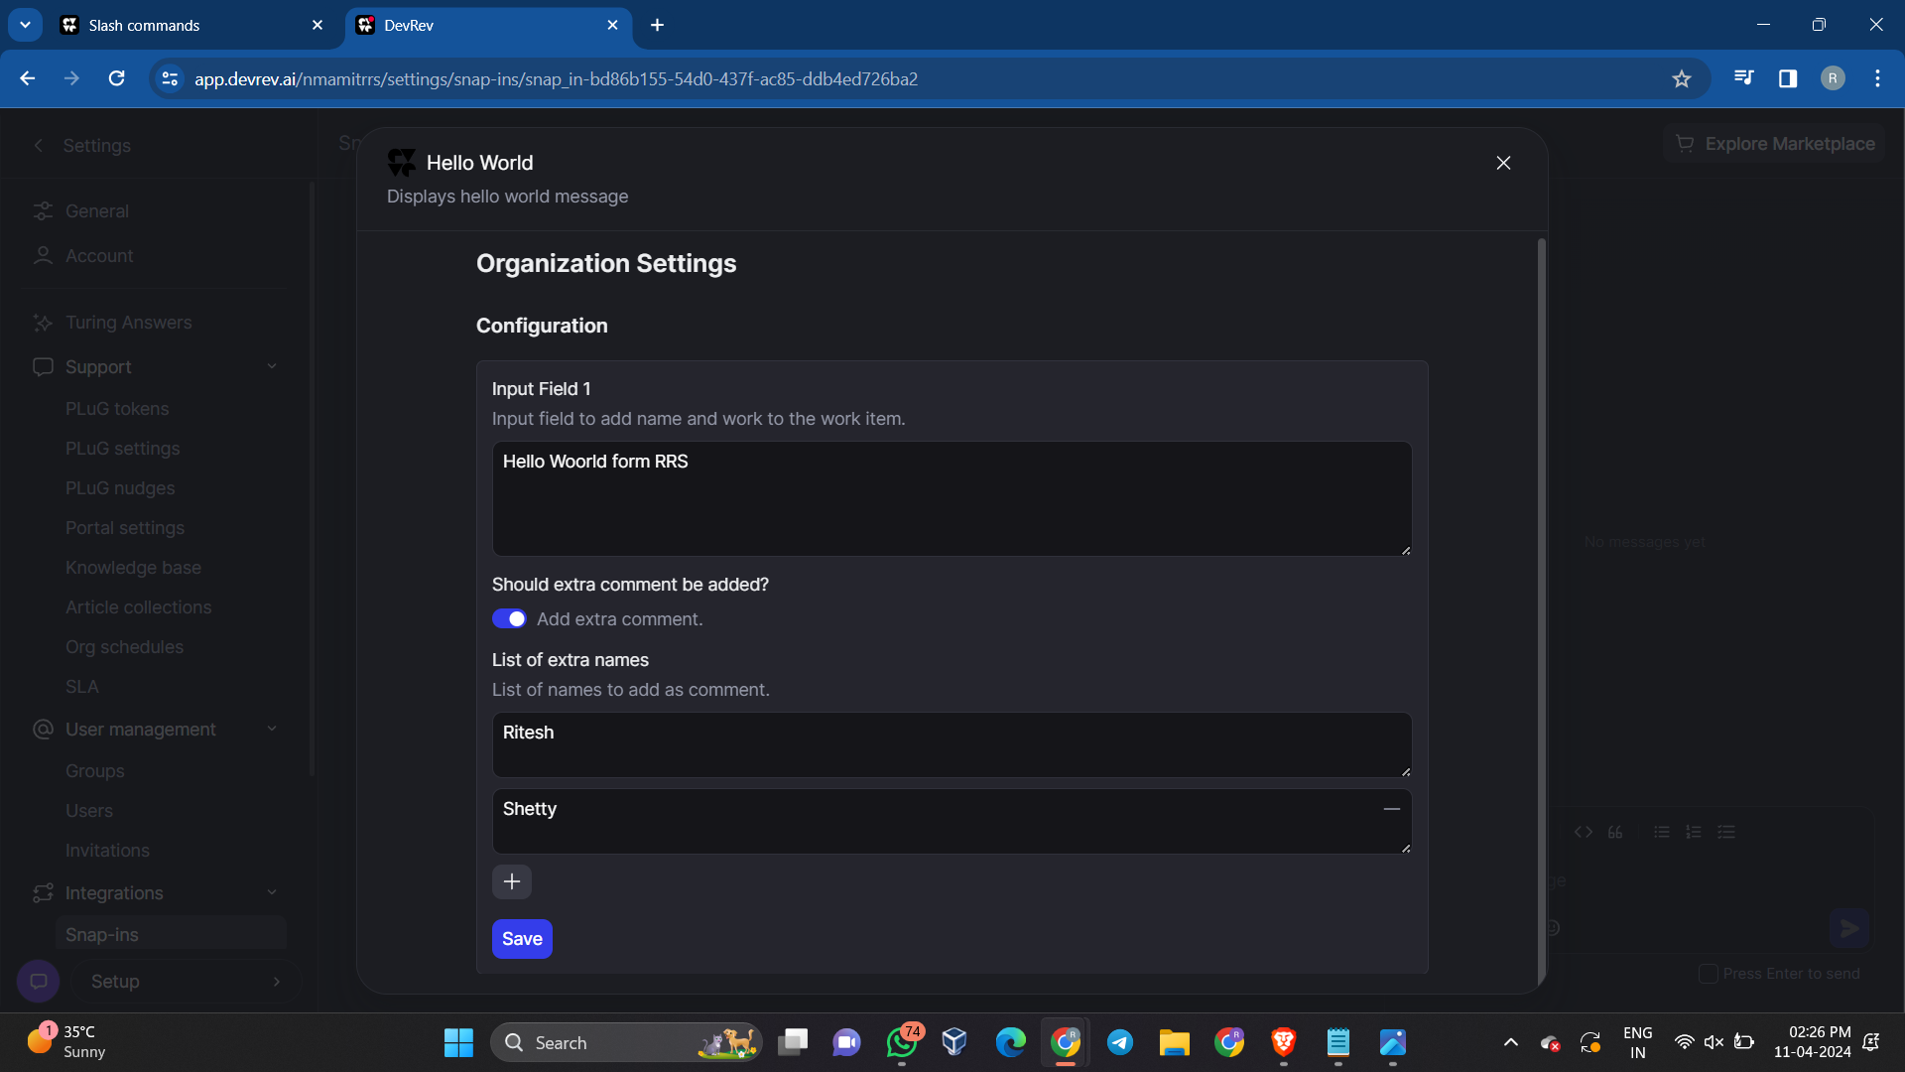

**Go to Issues or Tickets or anything else as per the compatablity and create a new item:**

Hello world gets executed, this is a automated reply provided by the snap-in (Method-1)

**For Issues:**

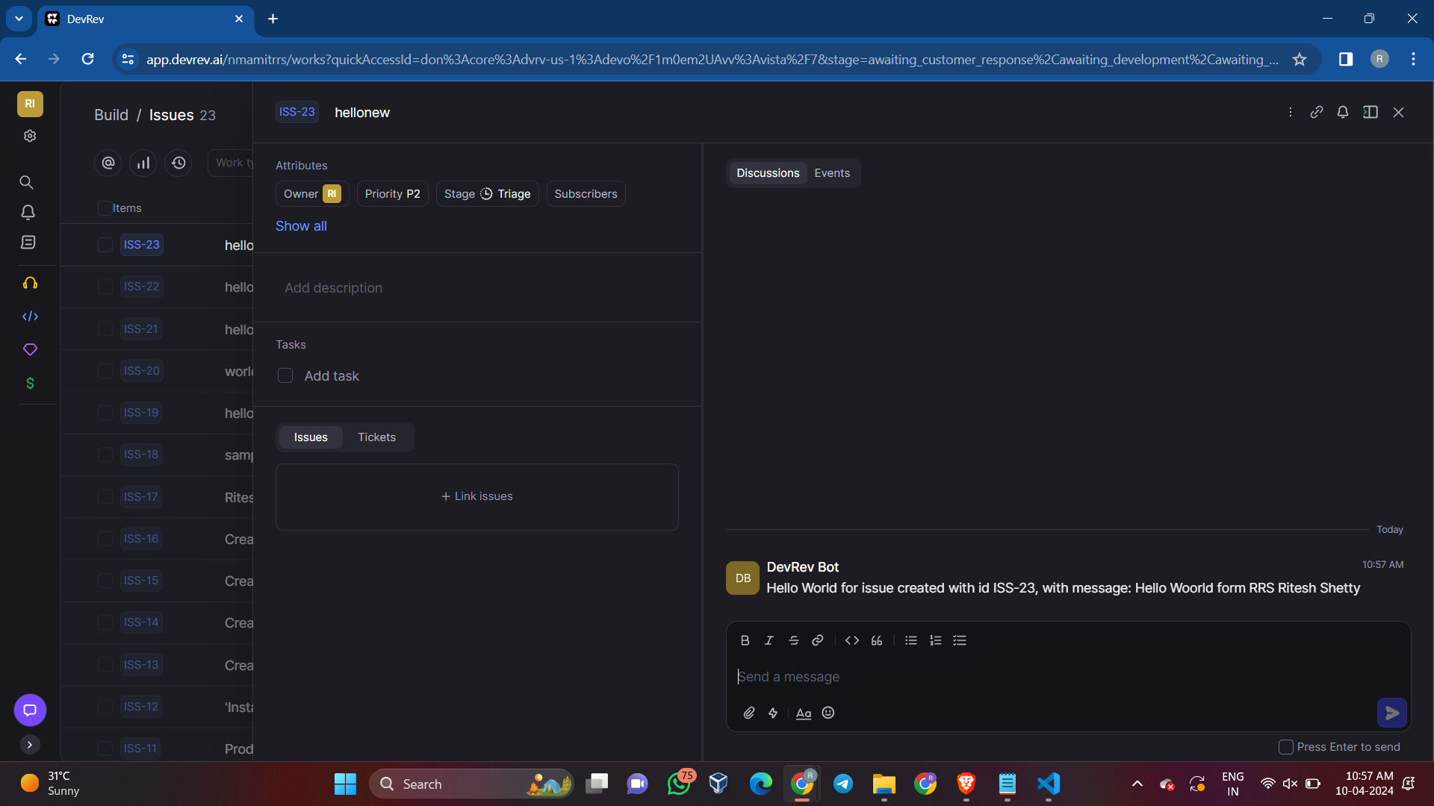

For method 2 , using slash command, click on the input box provided and type ’/’, list of all the slash command will be visible

Select helloworld slash command and execute

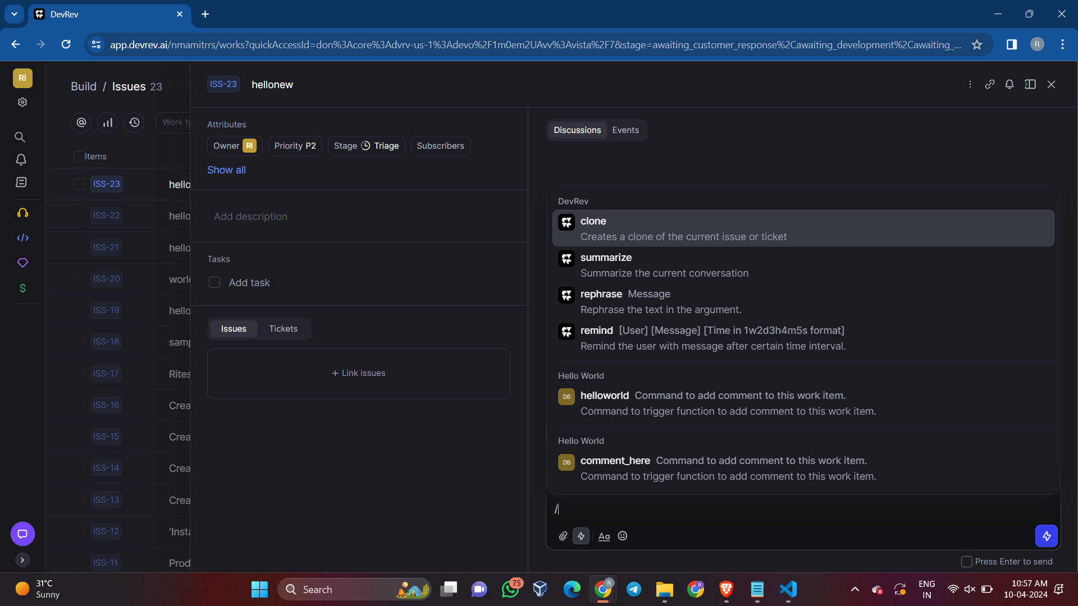

**Method 2 output using slash command**

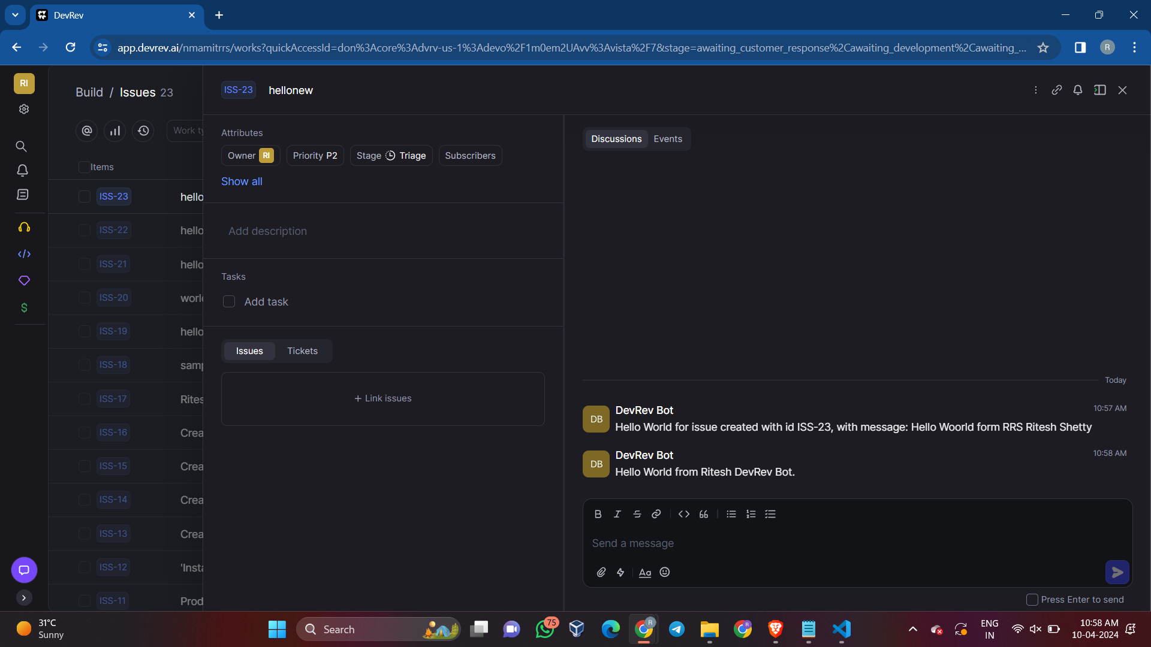

**For Tokens:**



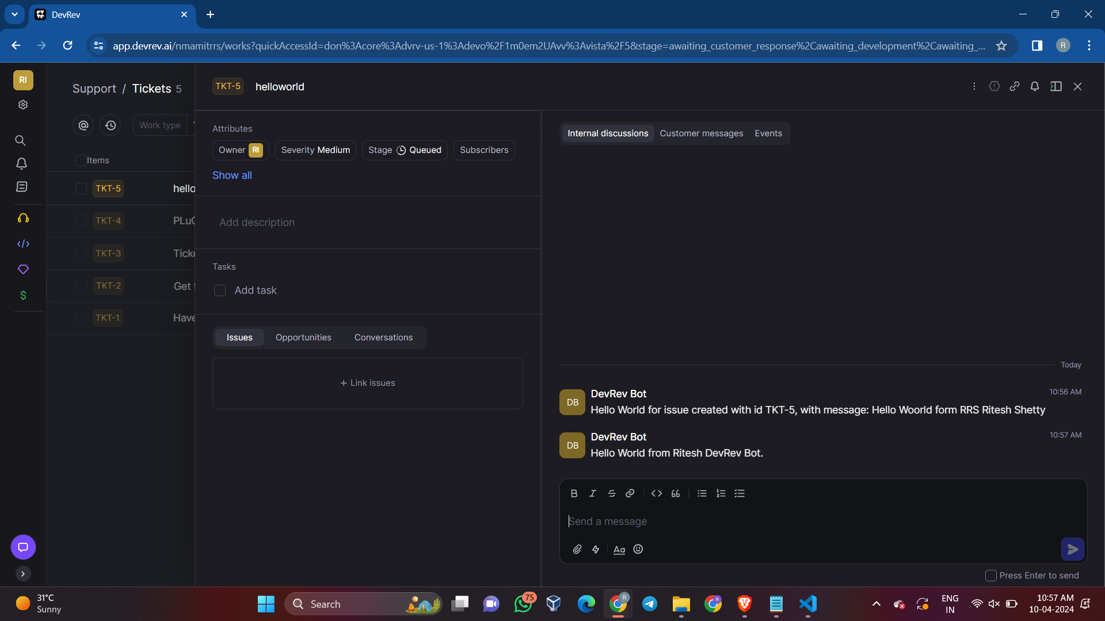

**Output for Snap-in:**

* Configure the snap-in in setting
* Deploy the Snap-in
* Come back to the Main page
* Either create a new Issue or Ticket
* Within it execute the slash command or function defined

1. **Schedule a reminder for someone by tagging them on a work item after MM HH DD time. Where MM is the minute, HH is the hour and DD is the time.**

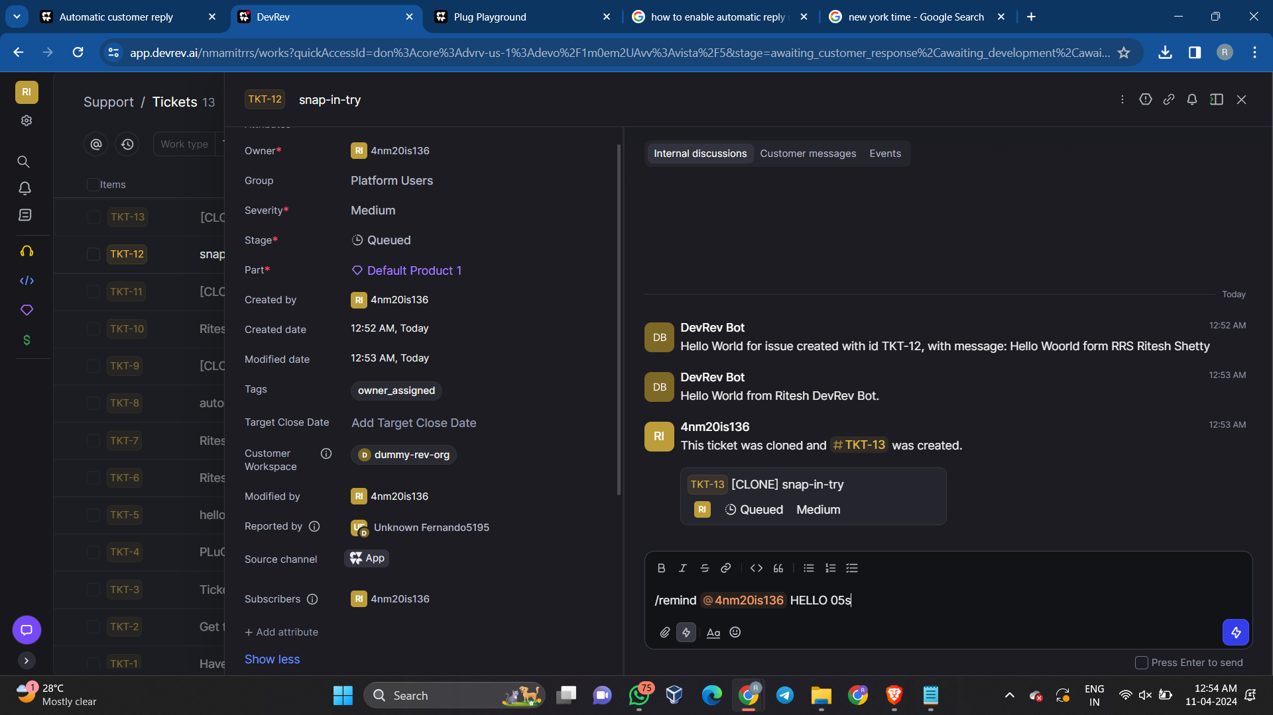

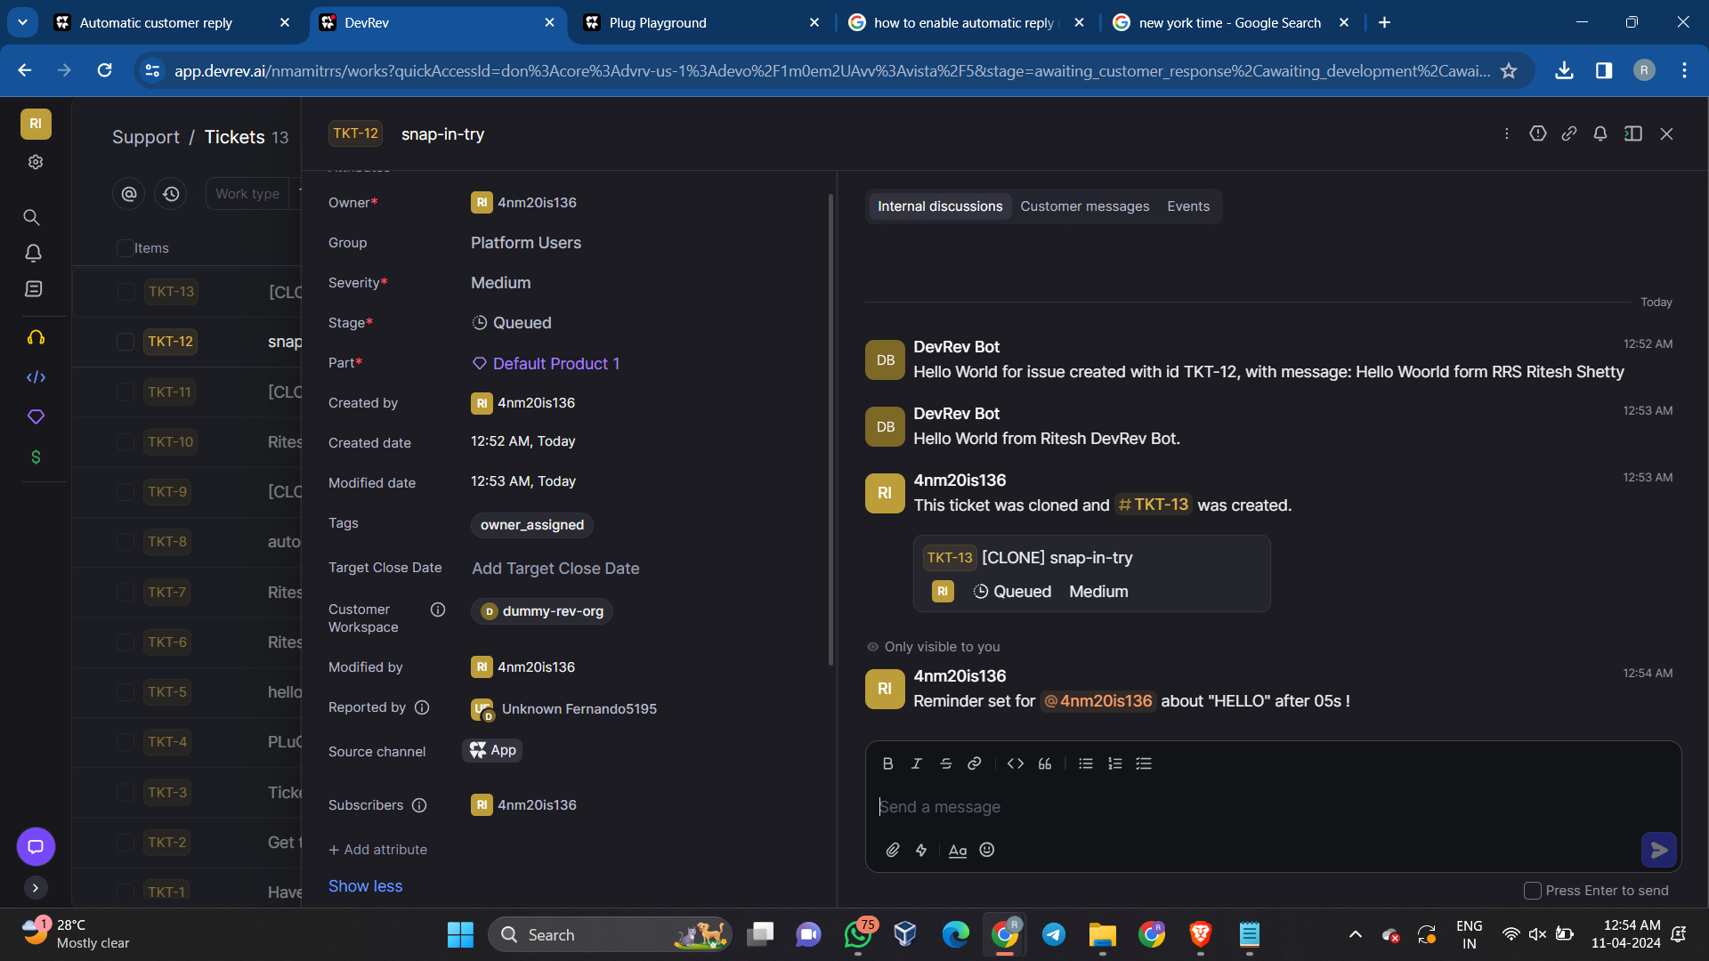

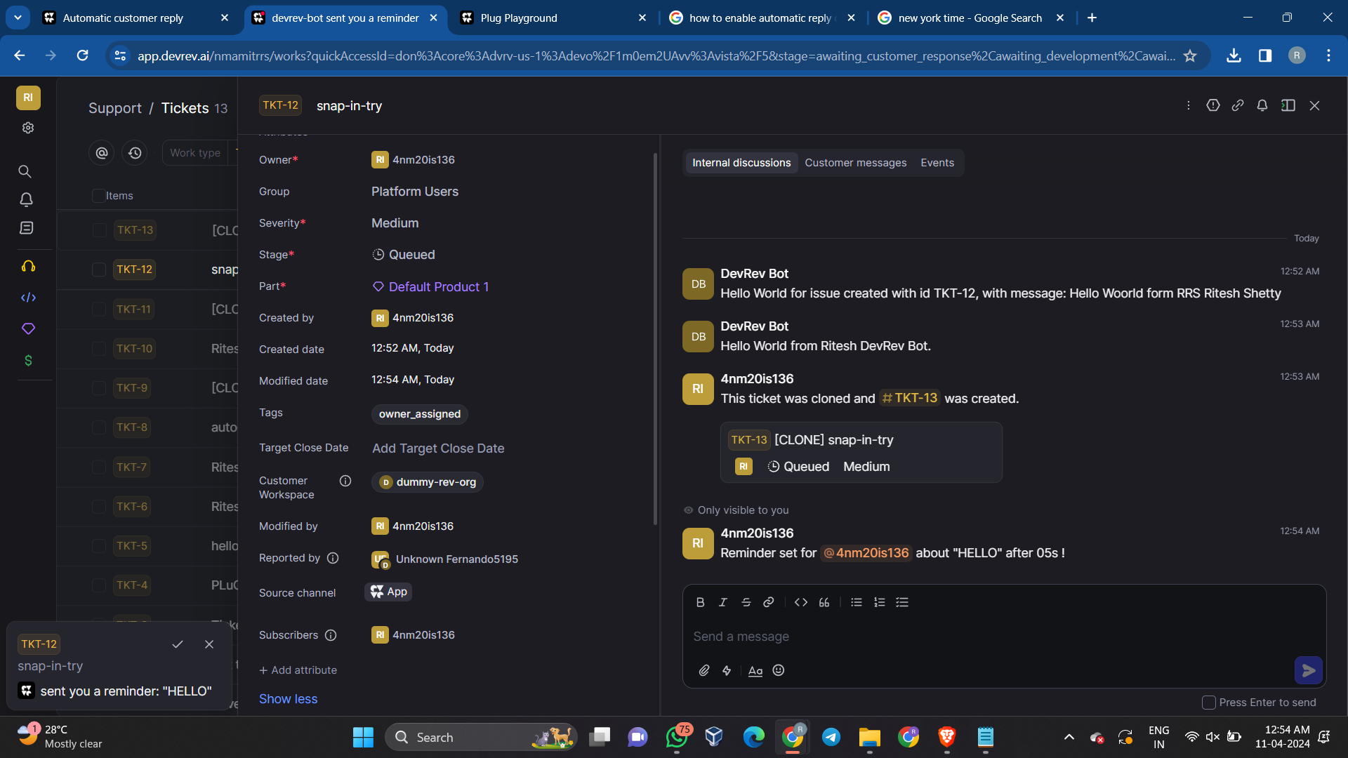

1. **Command to clone a work item (issue/ticket).**

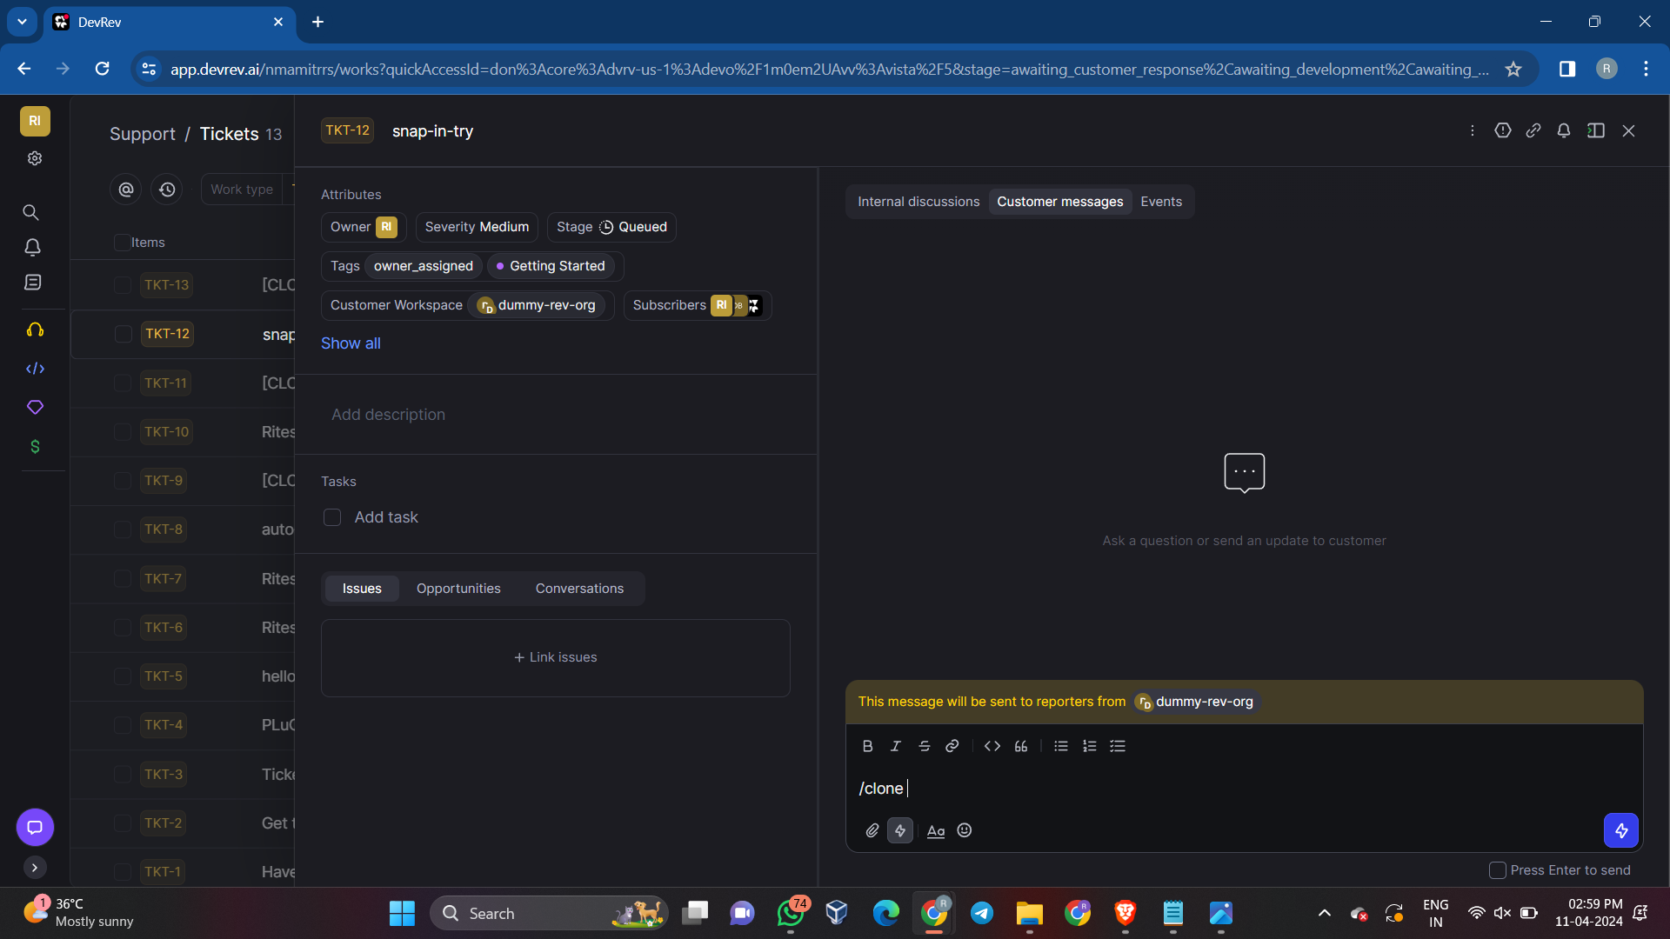

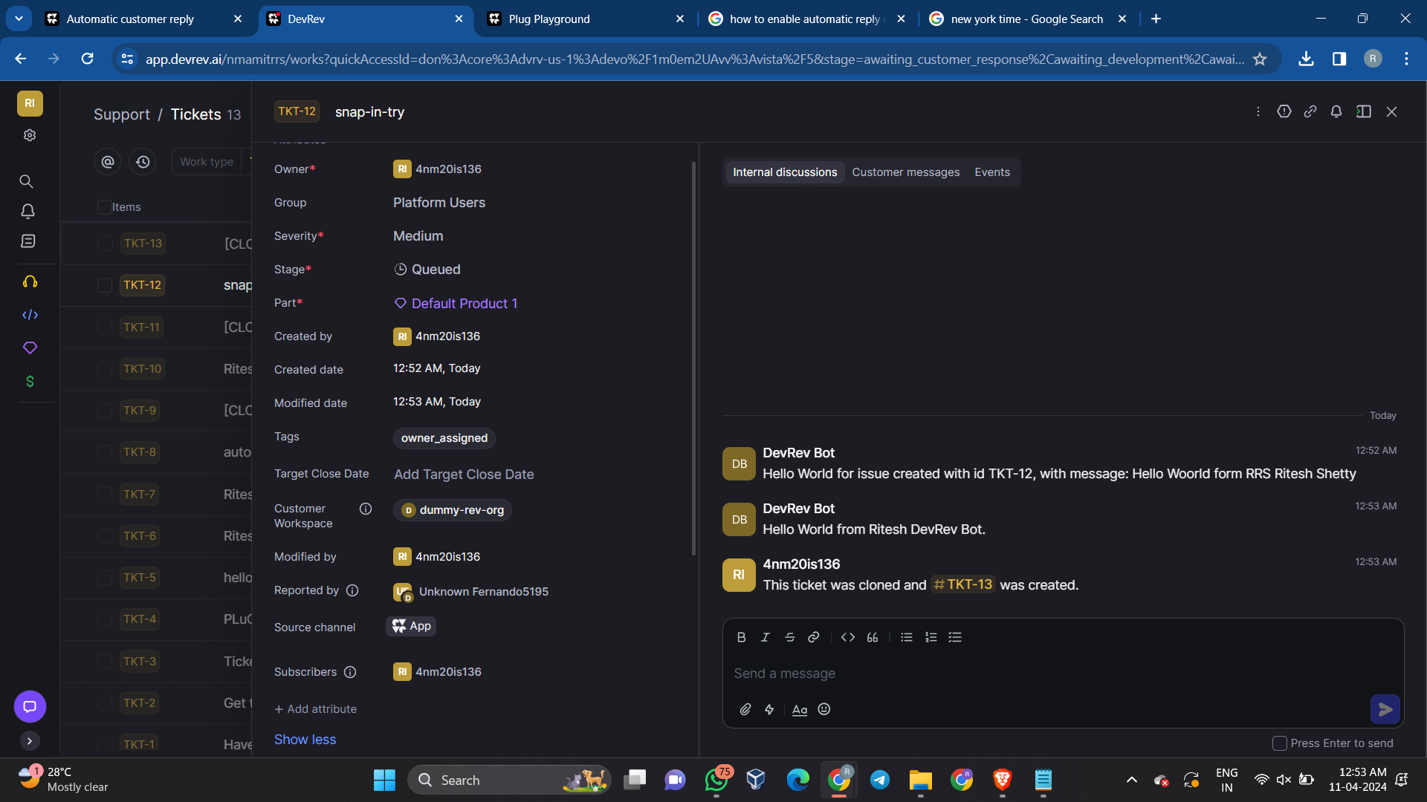

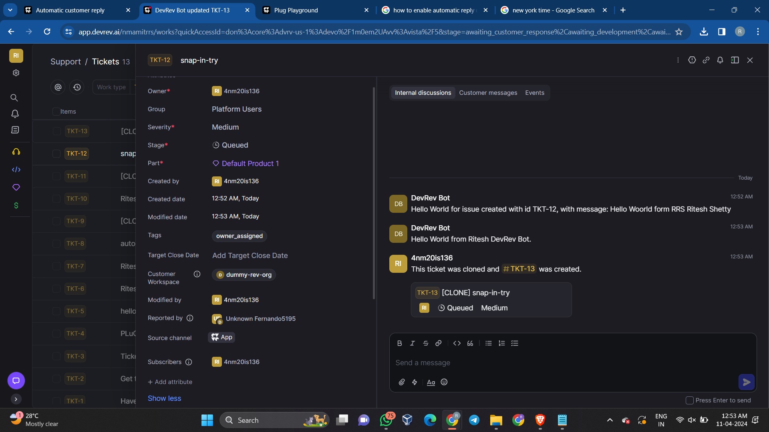

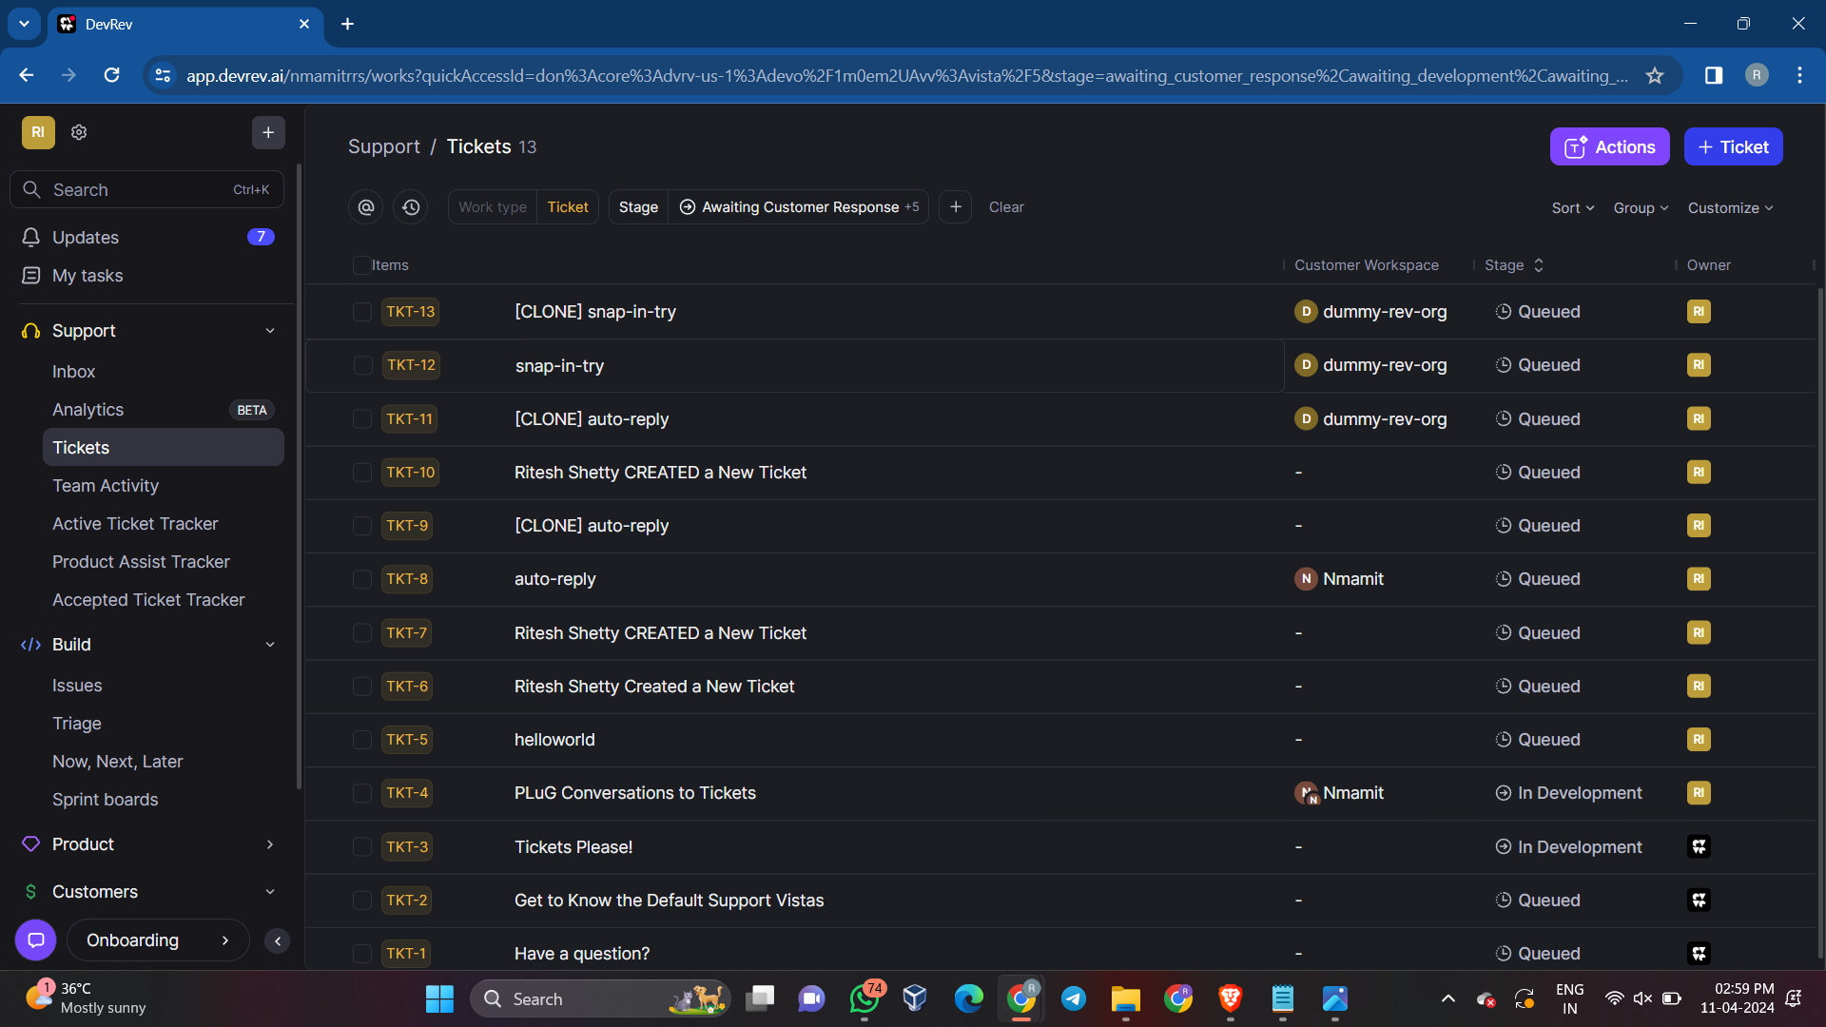

1. **Auto-Reply to a message if it is outside office hours. The start and end time for office hours can be specified in the input. The auto-reply message can also be taken as an input.**

**Configure the Snap-in**

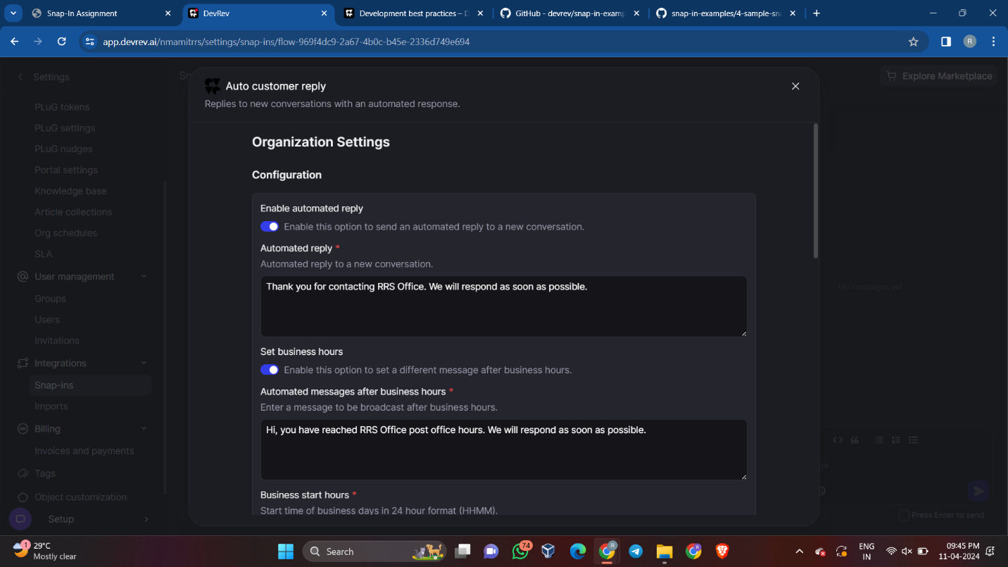

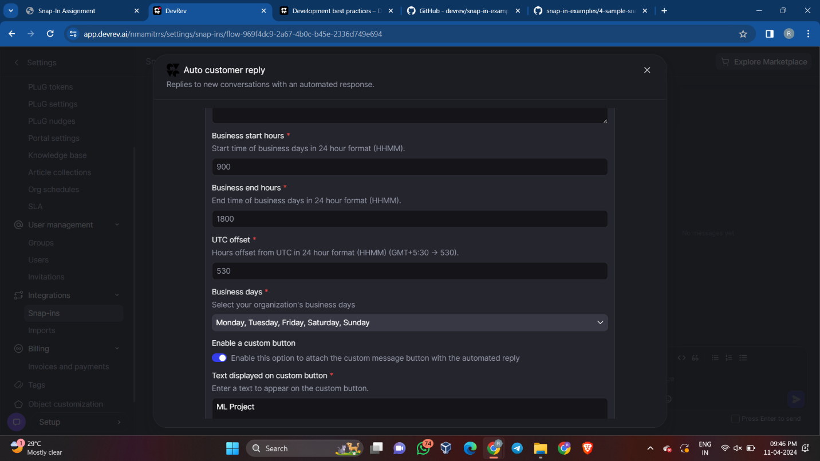

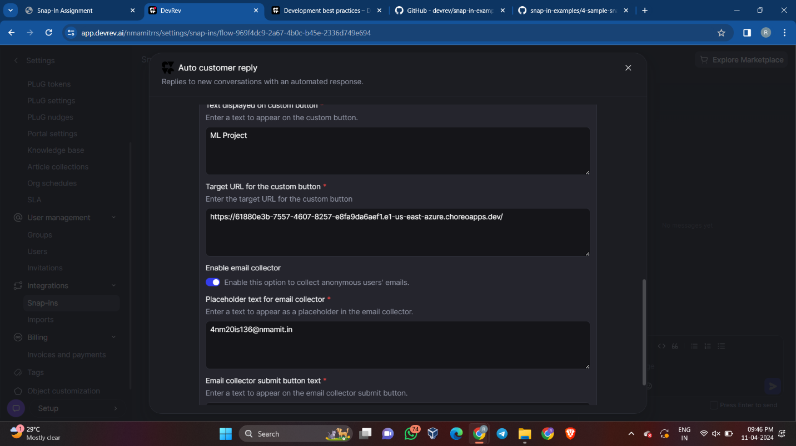

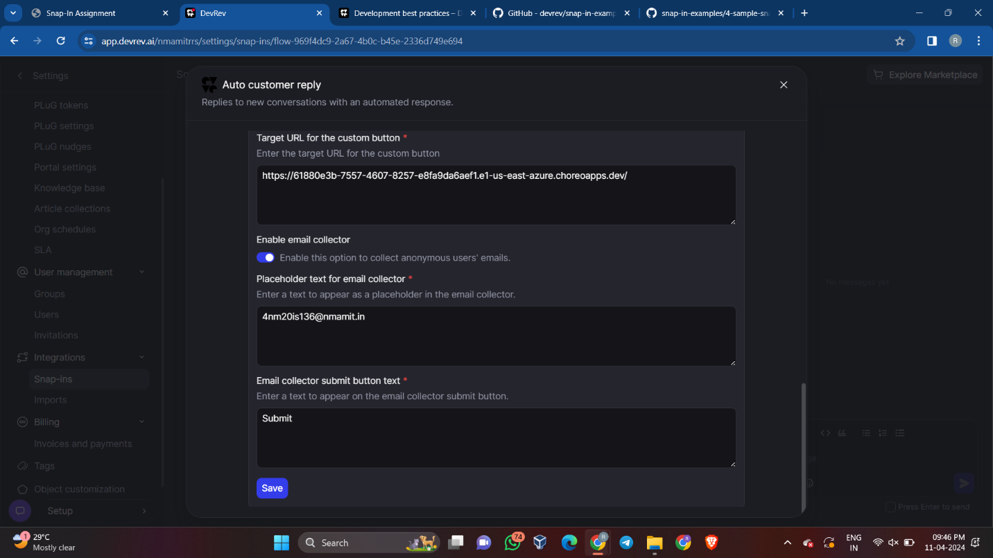

**Setting a PLuG in DevRev**

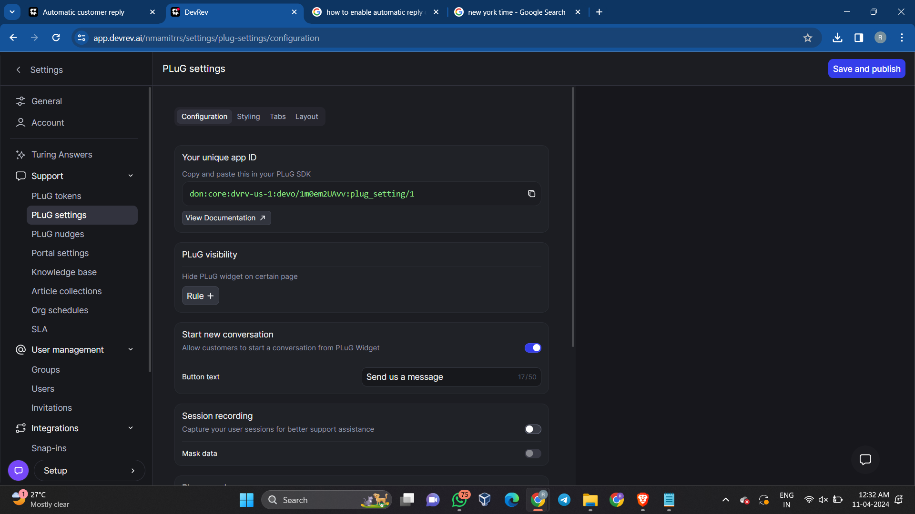

**With PLuG:**

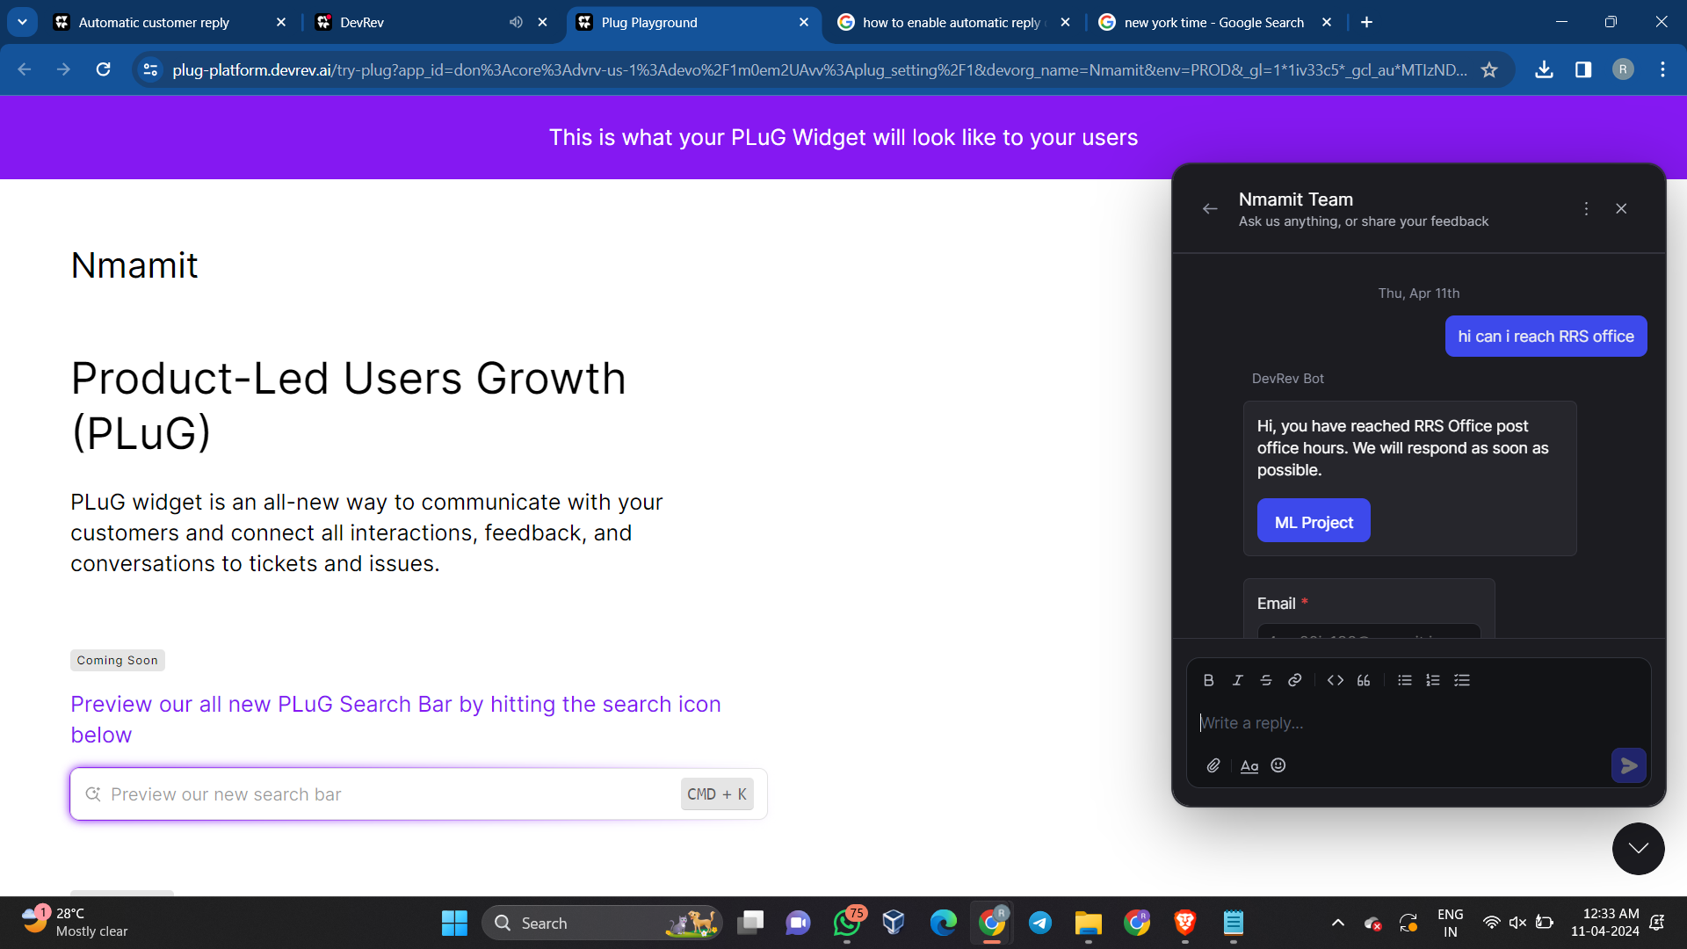

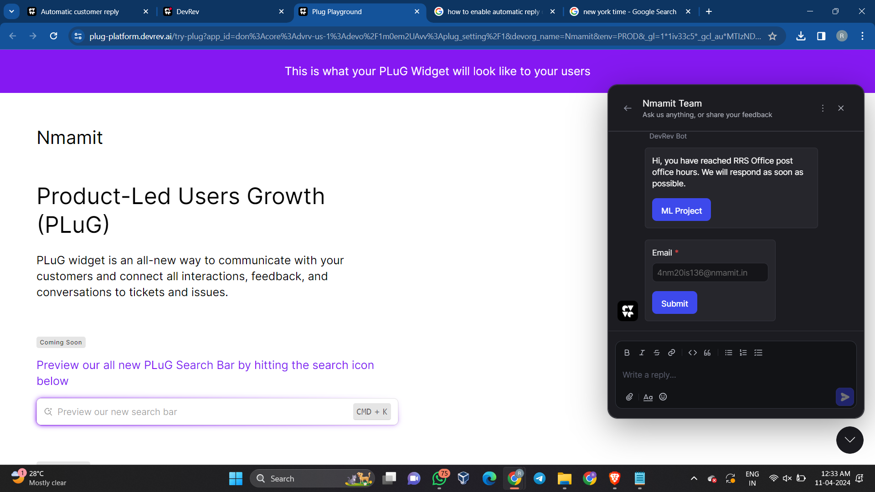

**Without using PLuG:**

**Create a New Customer Conversation under Support > Inbox on the Main Page**



